AI Phone Home



Dr Dobbs and Pentel Brush Pen with Prolog, Lisp, and Java

Jocelyn Ireson-Paine
www.j-paine.org

About these Cartoons

Since March 2008, I've been blogging for Dobbs Code Talk: the online incarnation of a hobby-computer journal that began in 1975 under the splendid title of Dr. Dobb's Journal of Tiny BASIC Calisthenics & Orthodontia: Running Light without Overbyte. I’ve also blogged a few cartoons, and the ones in your hand are they. Not surprisingly, they tend to be about computing. The online copies are at www.j-paine.org/dobbs/ . Because there aren’t so many cartoons yet, I’ve also included some essays.

I drew most of the cartoons, and most of each cartoon, with a Pentel Brush Pen. Thanks to Oxford’s Brush & Compass, now merged with Broad Canvas, for introducing me to this excellent instrument, and for maintaining a regular supply of cartridges as well as occasional replacement pens.

Jocelyn Ireson-Paine
www.j-paine.org
popx@j-paine.org

Scenes from a New Depression: Number Twenty-Seven

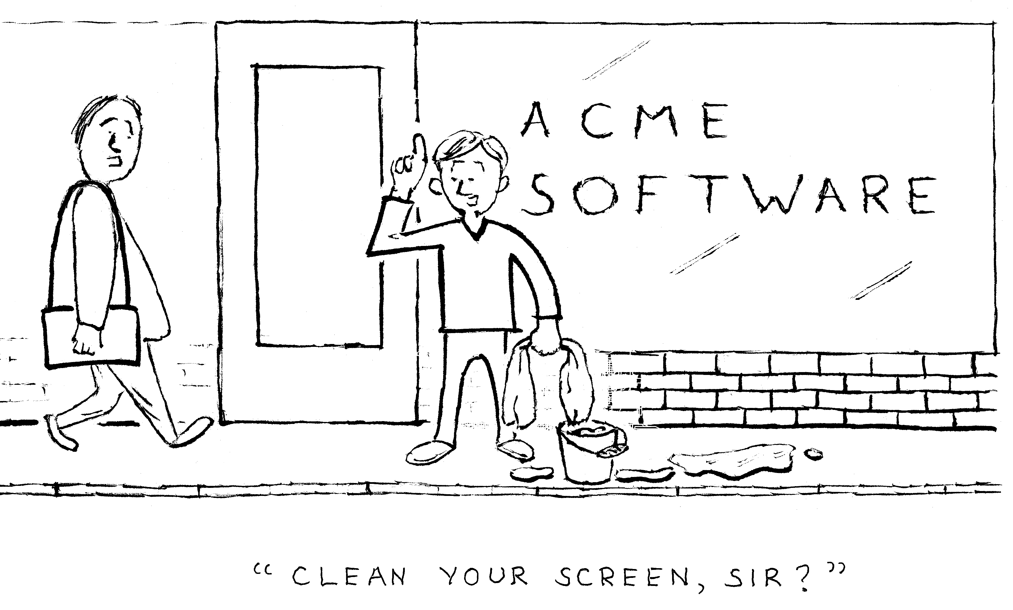

Happy New Year

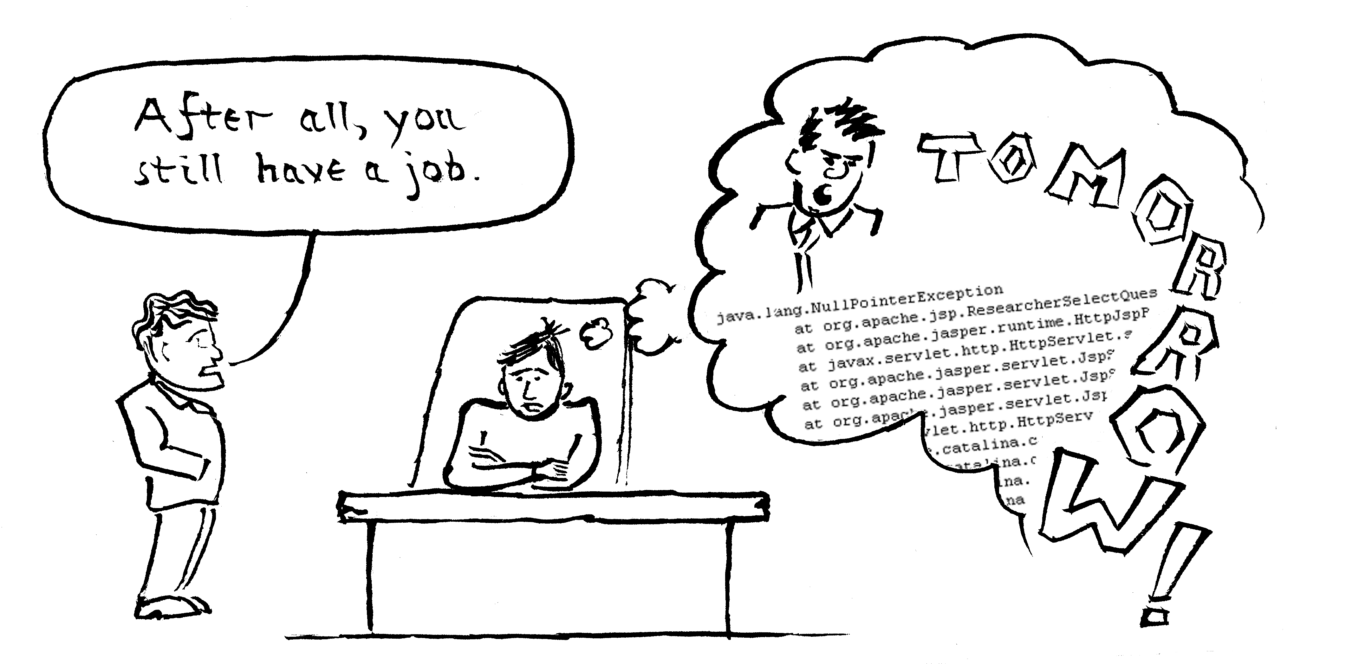

Intractability

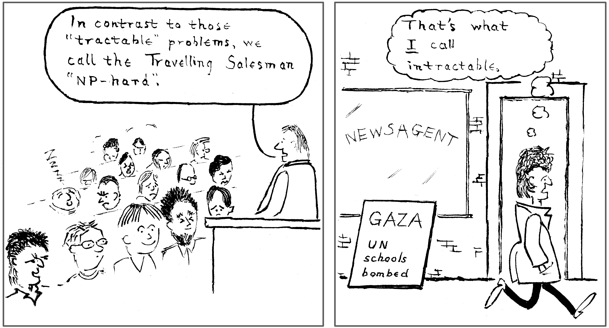

Filtering the Inauguration

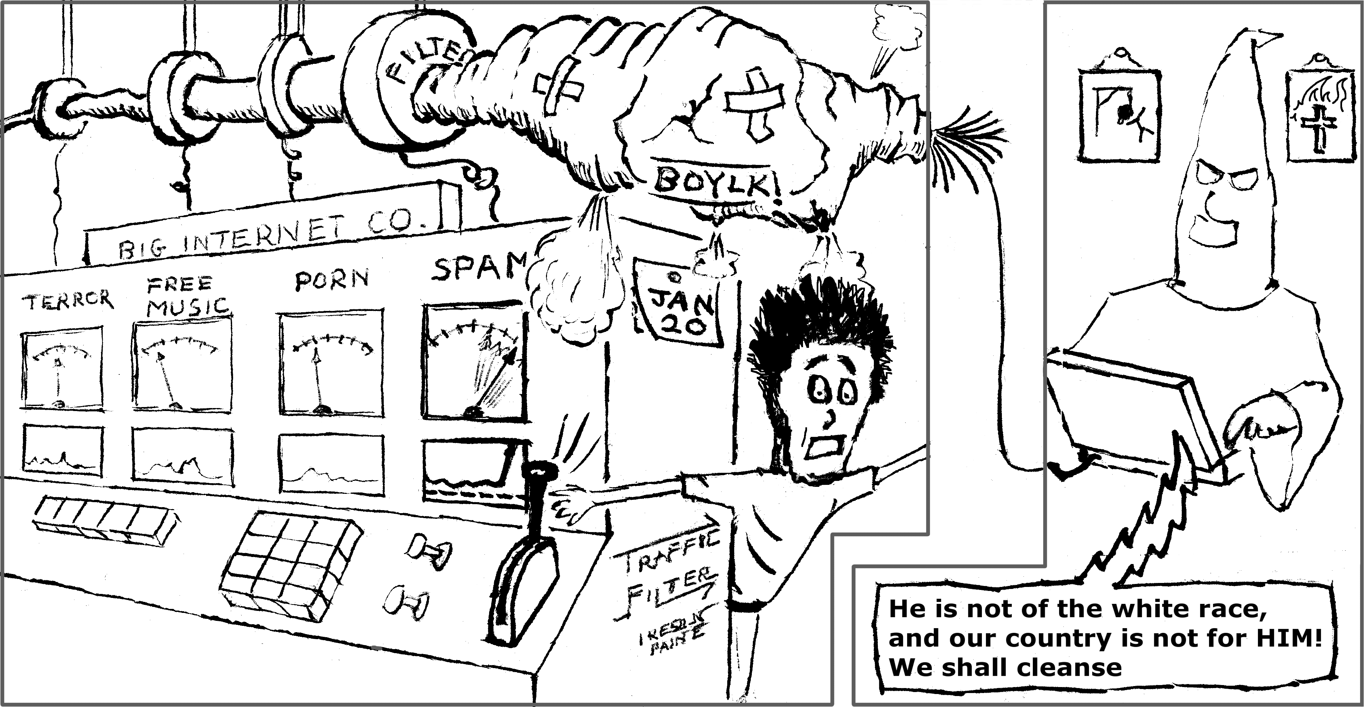
I wanted to entitle this Spam in a Klan, but decided it would give too much away. On the day Obama's victory was announced, one of my customers phoned urgently about problems with his Web site. One of these turned out to be a spamspike.
We do get spamspikes, his hosting company's owner told me. Sometimes, spam shoots to ten times its normal level. As it had this time — anti-Obama hate-mail and death-threats, courtesy of the American Far Right. Perhaps my drawing is unfair, symbolising them as I did. If so, I apologise to the Ku Klux Klan.
But not, I feel, to all of it. Read down to the end of the Imperial Klans of America International Headquarters page at www.kkkk.net . It is scary. Even the animation at the top is scary.
I can never remember whether to say "Klux" or "Kux". But now it's easy to remember, because Wikipedia tells me the name is from κύκλος, Greek for "circle". Also, I have never been inside an Internet hosting company. Some details in my drawing may therefore be wrong.
Fatal Addition

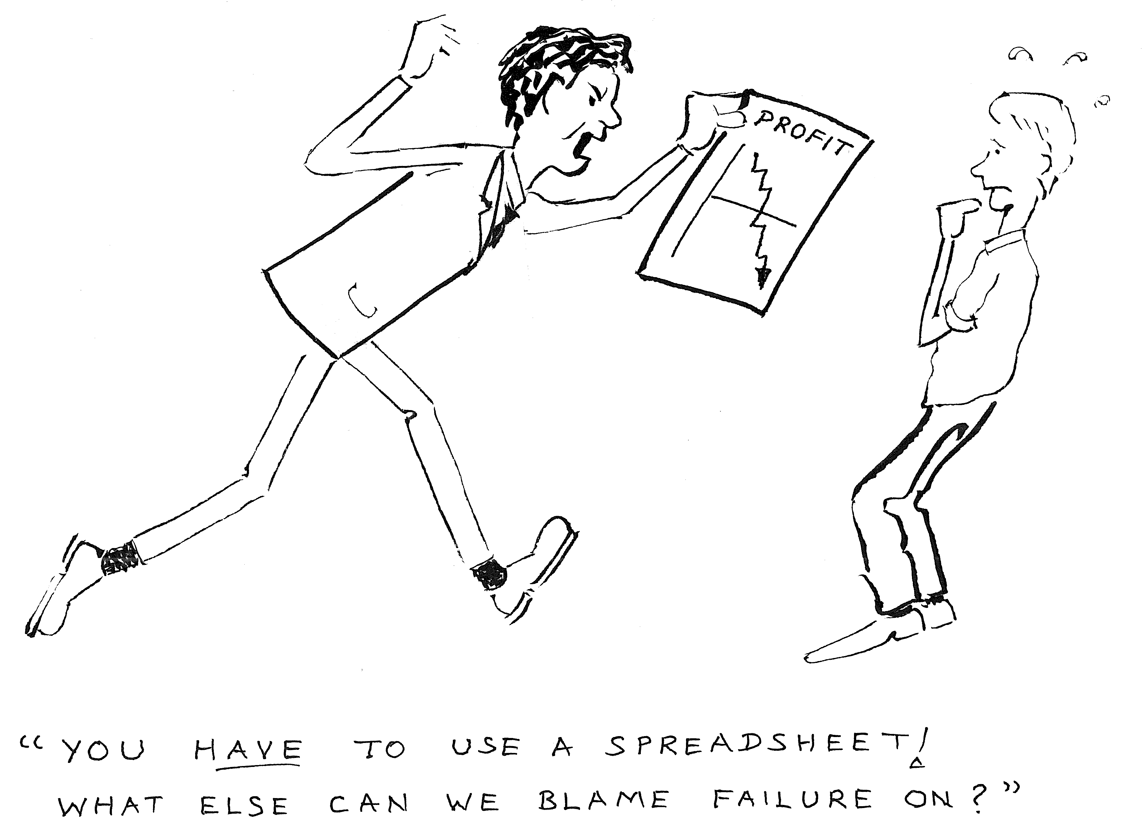
I've pinched my title from a feature in New Scientist for 6th August 1997 which reported on research into spreadsheet errors. Professor Ray Panko at the University of Hawai'i had examined ten years of spreadsheet-error studies and found every one to show a dangerously high rate of errors. He estimated that humans make around one error per hundred spreadsheet cells.
Accountants Coopers and Lybrand found errors in 90% of the spreadsheets they looked at.
And the Computer Audit Unit of HM Customs and Excise also found errors. In only 11% of spreadsheets — but some errors ran to millions of pounds.
The fault is with the human brain, never evolved for worlds where small errors can lie unnoticed for years, then return and bite you a millionfold. We can do nothing about that. But perhaps we can design more helpful software…

Did Spreadsheets Crash the City?
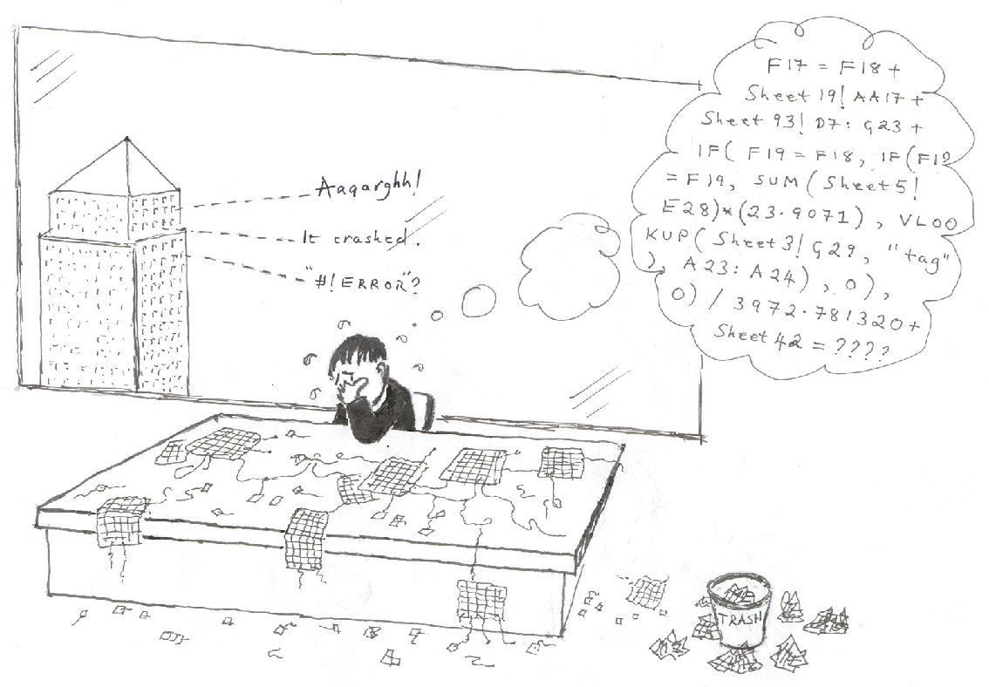
I’ve been researching into techniques for building spreadsheets more safely, which is why I have spreadsheet cartoons. A good way to make any system safer to build is to use prefabricated components, tested and documented. Even if these aren’t free, the money spent buying them is probably less than the wages saved — if you doubt this, try building a radio from transistors you fabricated yourself. And, once you have finished a complicated system, you help others by breaking it down into components they can reuse.
Computing calls program components “modules”, and speaks of “modular programming”. Sadly, the world’s most popular spreadsheet, Excel, lacks modules. If you write an Excel spreadsheet and want to give your code to someone else writing an Excel spreadsheet, you must copy and paste cells into their spreadsheet. Not possible if the shapes and positions don’t match, and always likely to cause errors. So I was pleased when I developed software to solve the problem; and I drew this cartoon for the European Spreadsheet Risks Interest Group conference where I showed off that software.
The conference opened on July 7th 2005 in Greenwich, opposite Canary Wharf. Around eleven on that dreadful morning, we learnt of the bombings. The more terrifying because rumour flew. We were told London was in “lock-down”, no-one allowed in or out. The conference chairman asked me whether I thought it tactless to show the cartoon. Does anyone see why? I don’t.
Spreadsheets Need Modules

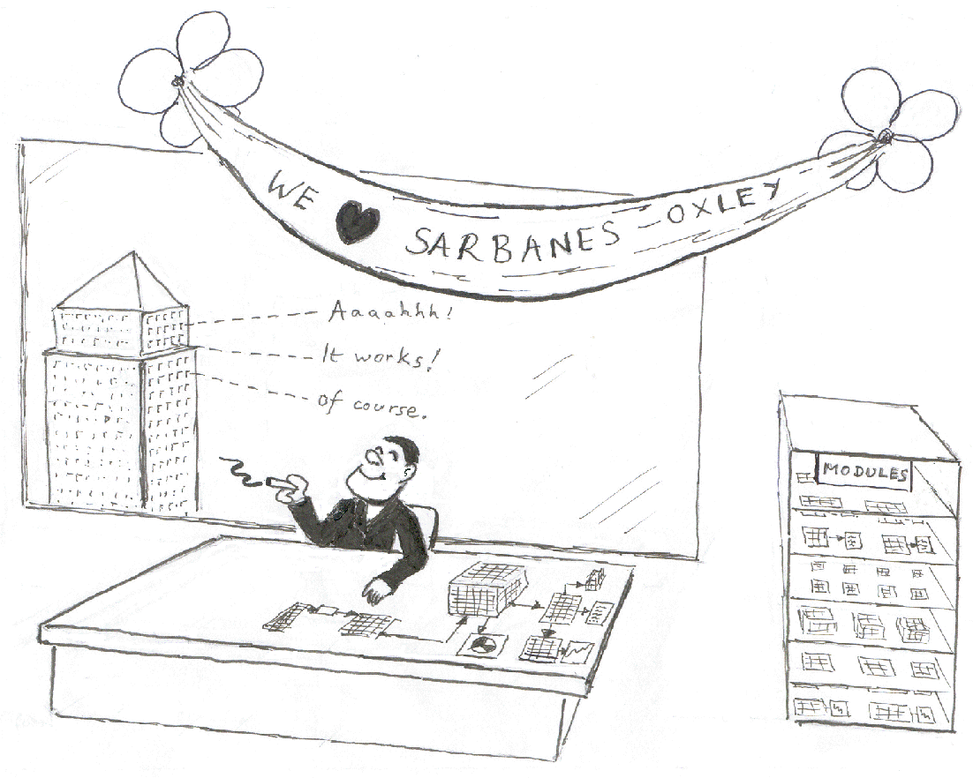
The previous cartoon was “before modularity”; this one is “after modularity”. Sarbanes-Oxley, by the way, is a piece of US law enacted in 2002 in response to Enron and other accounting scandals. It set more stringent standards, and penalised companies more highly for accounting errors. This made it even more important to know one’s spreadsheets are correct. Unless you like jail.

Poem on the Determination of Consciousness
I know that I am conscious, for I can feel me be.
I think my friend is conscious, for he looks much like me.
Perhaps my dog is conscious;
he's soft and biological, a mammal close to me.
But surely Cog's not conscious?
Ten million lines of C++, a neural net, a metal bus,
enclosed in a PC?
Cog is the robot developed by Rodney Brooks and others at MIT Artificial Intelligence Laboratory, Humanoid Robotics Group. I was thinking of Terrel Miedaner’s The Soul of the Mark III Beast, reprinted in Douglas Hofstadter and Daniel Dennett’s The Mind’s Eye.

An Ounce of Image

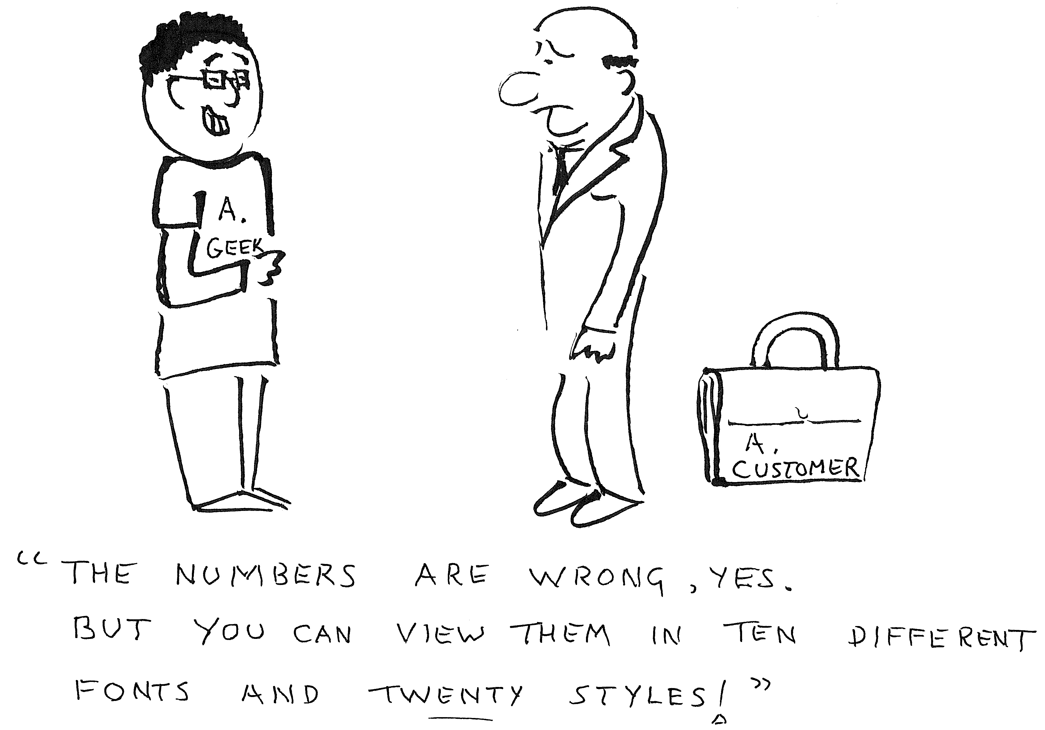
I drew this cartoon on a let’s-have-coffee note to catch my friend Julian Clarke’s eye during this year’s spreadsheet conference in Paris. It was inspired by a paper about teaching Excel to novices, by Étienne Vandeput of the University of Liège. Étienne says teachers often talk more about graphical-interface things than about calculations:
For instance, trainees learn to enlarge a column or to emphasise characters before writing a formula or thinking about the modeling of a spreadsheet. They are very surprised when a value does not appear in a cell like they thought it would, but they do not care about cell format and information types. They feel very satisfied when they get a pretty graphic even if it shows wrong values and so on.
In the words of the proverb:
An ounce of image is worth a pound of performance.
By the way, I can see why the French live longer than the English. At 9pm on the Monday, I was standing near Cathédrale Notre Dame in bright sunshine, admiring the flying buttresses and the views up and down the Seine. Plenty of time to meander back to the RER station, get back to the conference accommodation just outside Paris, and buy food from a local shop before dusk. At 9pm on the Tuesday, having emerged into London in the centre of a titanic hour-long thunderstorm, the first time I'd ever consciously noticed that lightning is blue, I was standing under a sky-sized raincloud, shivering. It felt ten degrees cooler. Dusk was reflected in the puddles on the pavement. This is why the French have joie de vivre whereas the English have tea and custard creams. Especially superb was the joie de vivre evident at our conference lunches. Our caterers provided it in liquid form — red, rosé, and white.

Bound to be Called

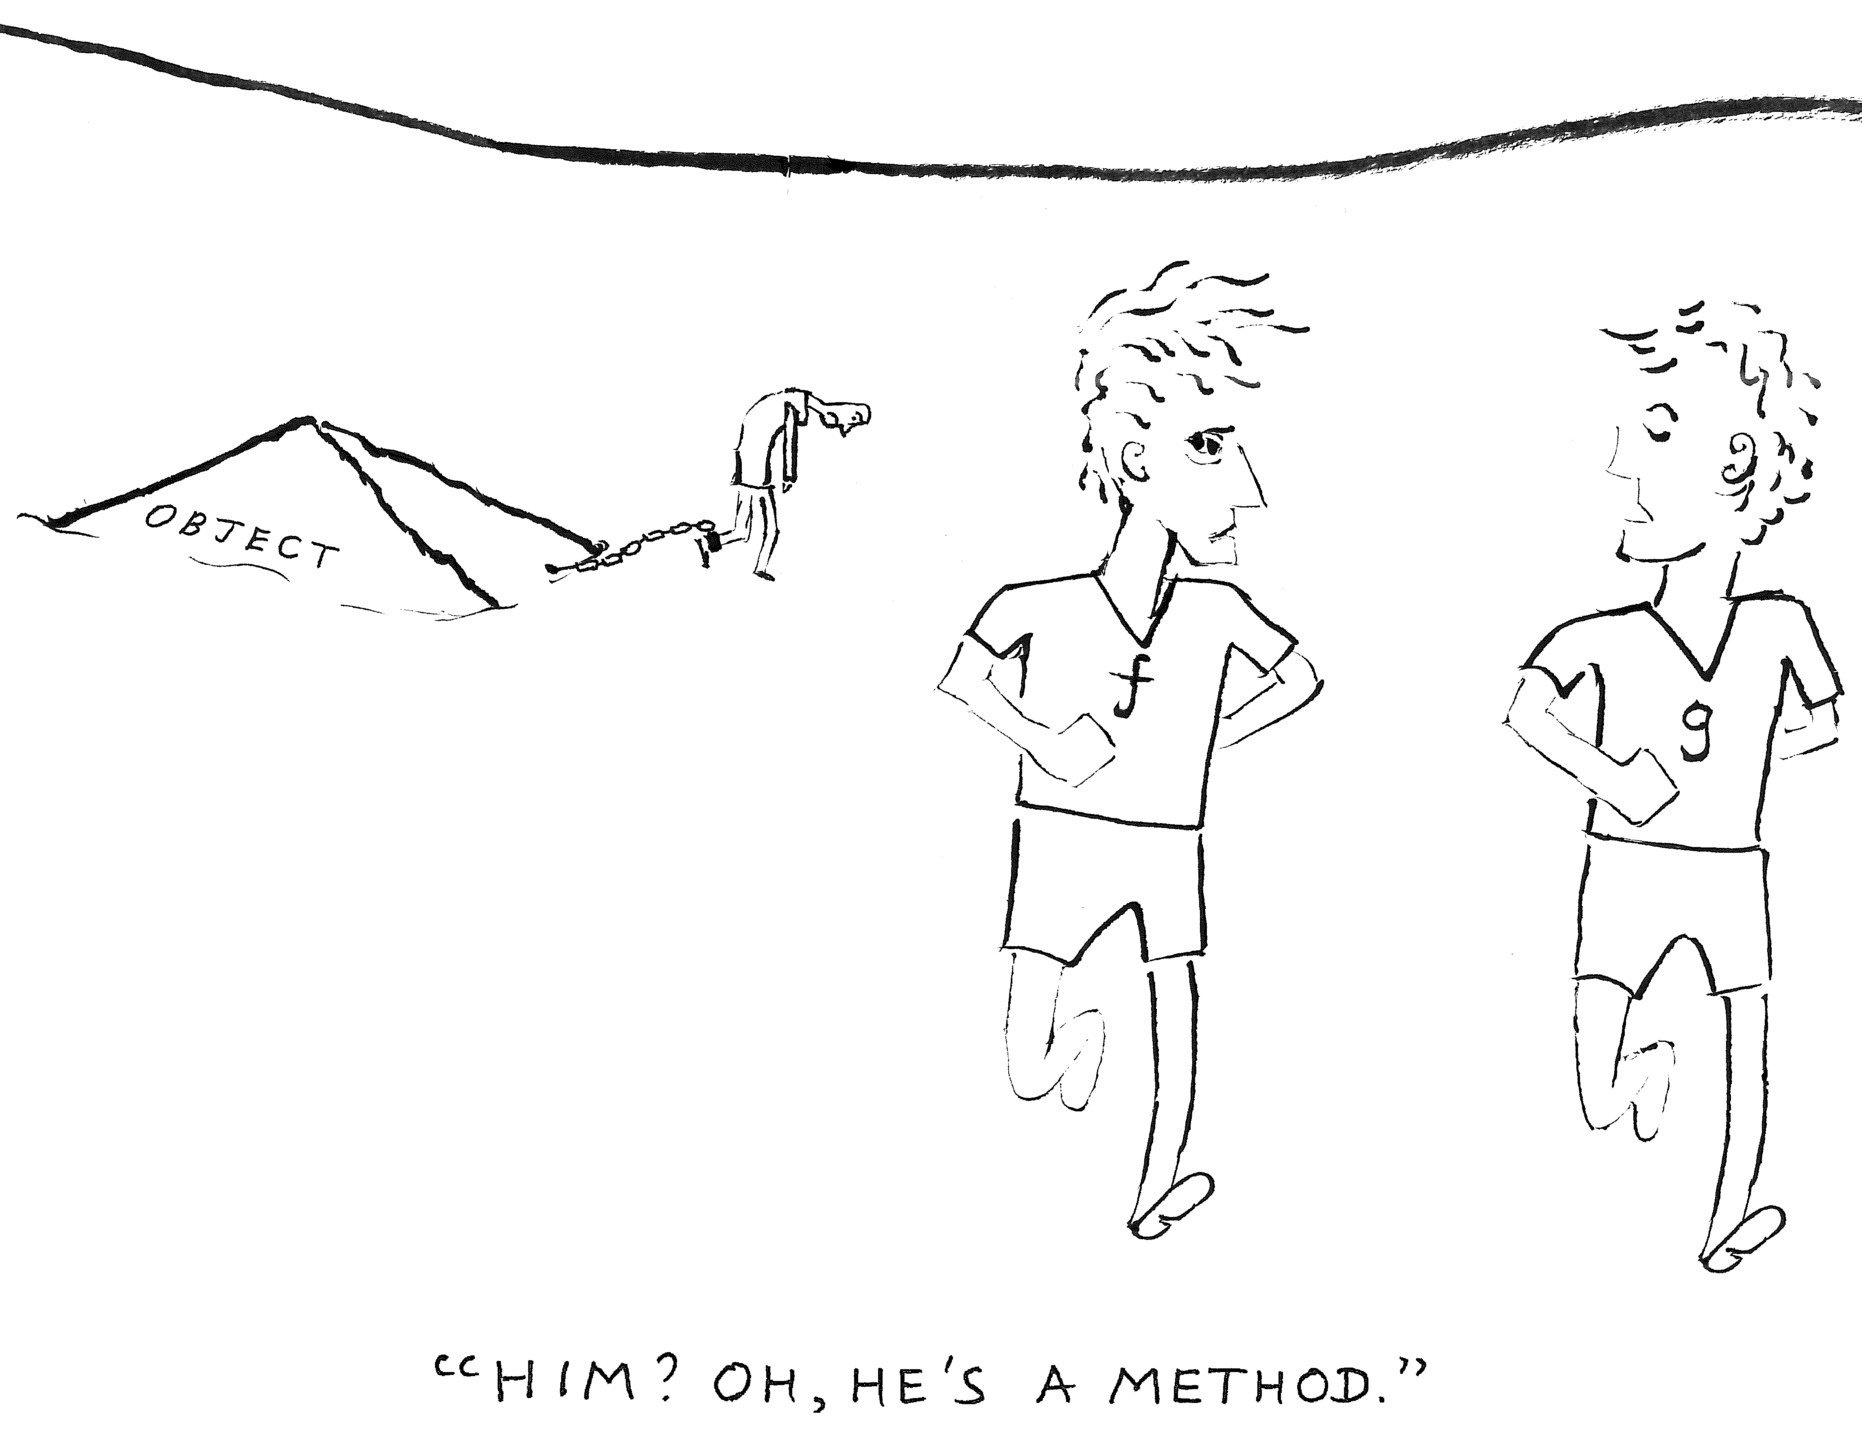

In the most respected programming languages, functions — such as the act of squaring a number, or of taking its cosine — are “first class values”. They can be stored in variables, and calculated with by passing them into and out of other functions. Such languages thereby become hugely versatile.

“Object-oriented languages” such as Java, on the other hand, put functions in bondage. They name them “methods” and tie them to objects, making it impossible to use them freely. This has never seemed sensible to me — function is, after all, only the most important concept in the whole of mathematics. It didn’t seem sensible to Dobbs blogger Bill Lewis either, who posted a piece about it titled How much would you pay for a closure? (“Closures” are a trick in computing that helps a language make functions into first class values.) So I drew this cartoon in sympathy with his views.

I Tweet, You're a Twit, He's a Tw*t

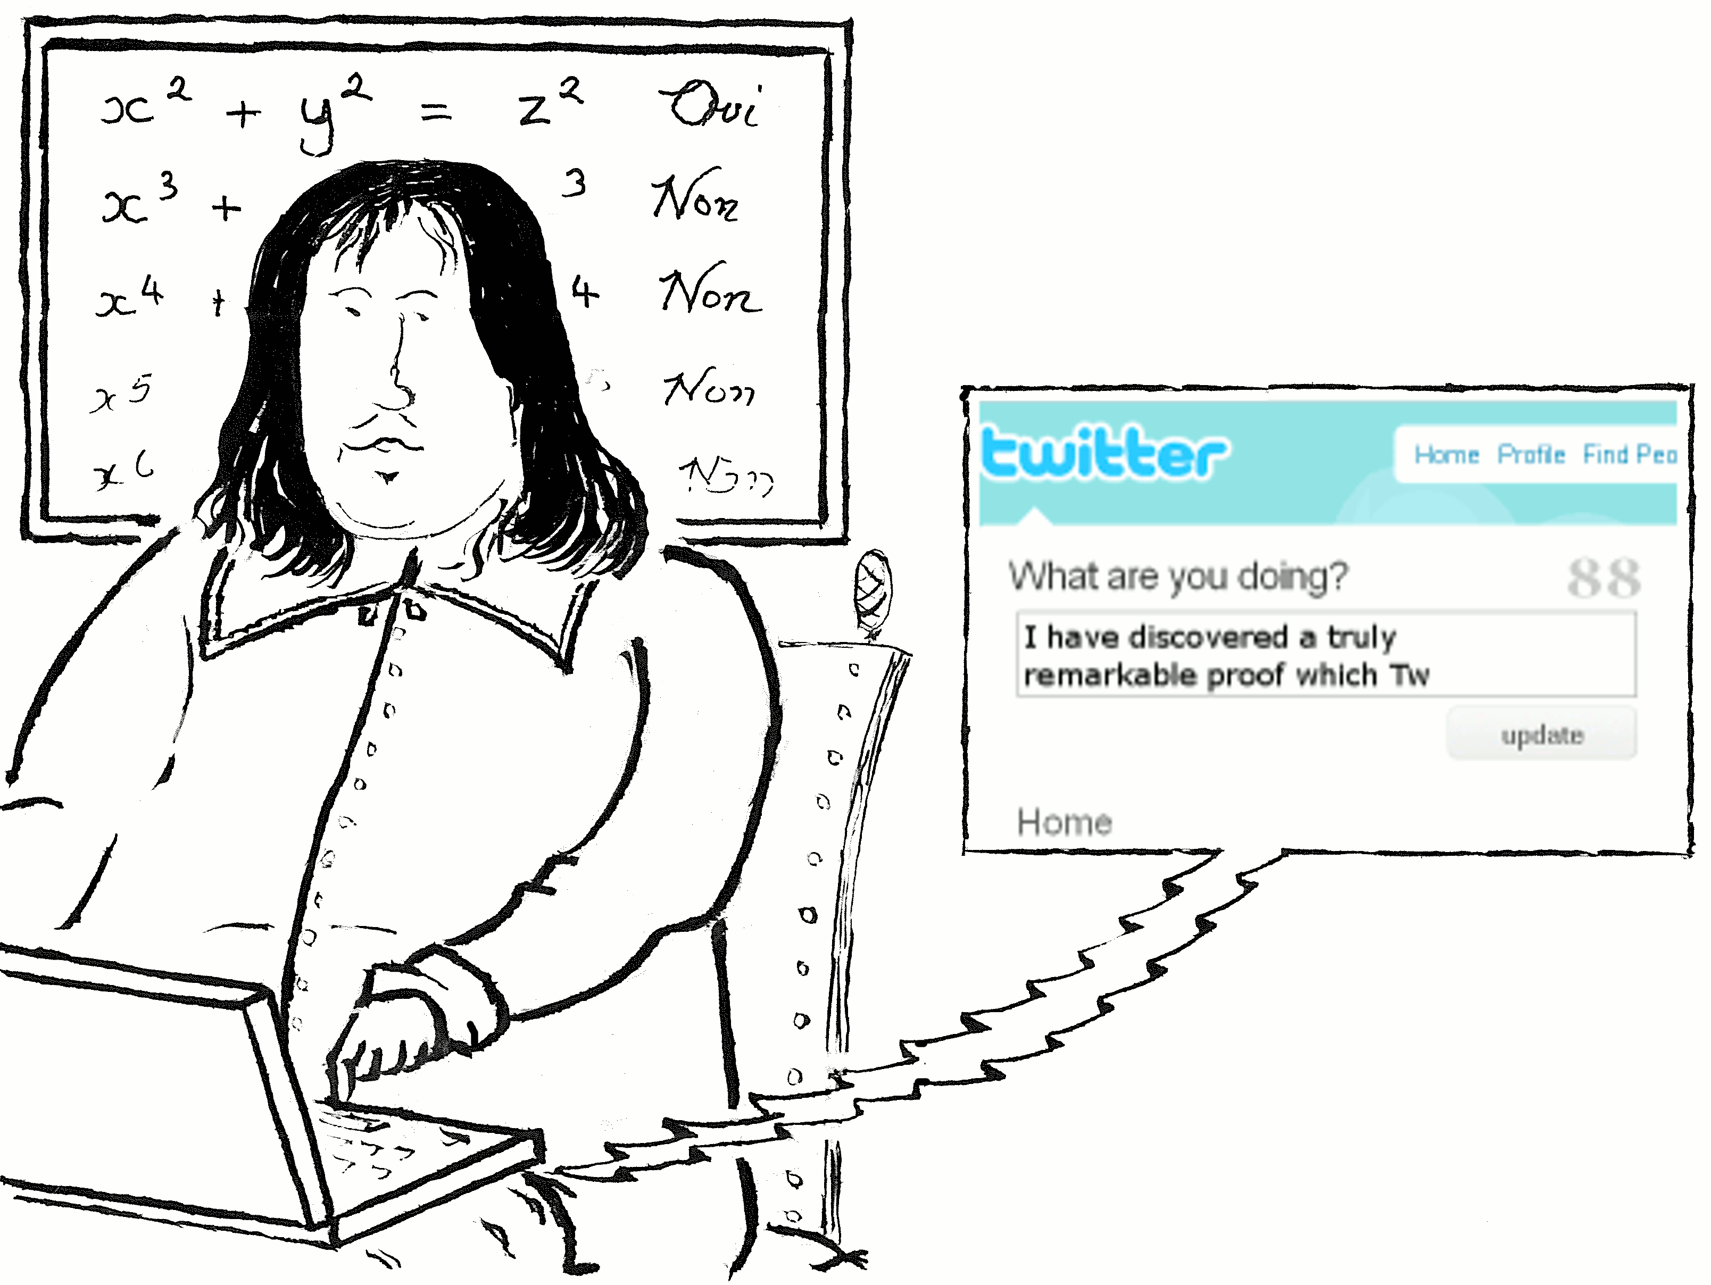
Twitter made David Cameron more notorious last week than if nabbed claiming an entire islandful of duck islands on expenses. Interviewed on breakfast radio, he uttered a word that despite denoting a piece of anatomy owned by half the human race, has been deemed so obscene that (I believe) it was once banned from radio:
The trouble with Twitter, the instantness of it — too many twits might make a twat.
Twitter has been on my mind since I read Spectator journalist Rod Liddle's feature It is the narcissistic middle-aged, not the young, who love Facebook and Twitter. Liddle says few teenagers use Twitter, because they realise how pointless it is to tweet personal confessions such as “I have just tied up my shoelaces. I did the right one first. And then the left.” It’s older people like Stephen Fry, Liddle says, who Twitter obsesses.
I don’t want to read Stephen Fry tweeting about the steak he ate for dinner. I also don't want my messages limited to 140 characters. Perhaps Twitter don't own enough storage to hold longer messages. Then they should hand over to Google. Google have so much capacity that they could issue every single electron with its own URL, and still have space in reserve to tag the extra electrons generated by pair production while the Universe is running. And the positrons.
But really, I find this restriction, and Twitter itself, as futile as forcing Fermat to write all his maths in margins.
Primed

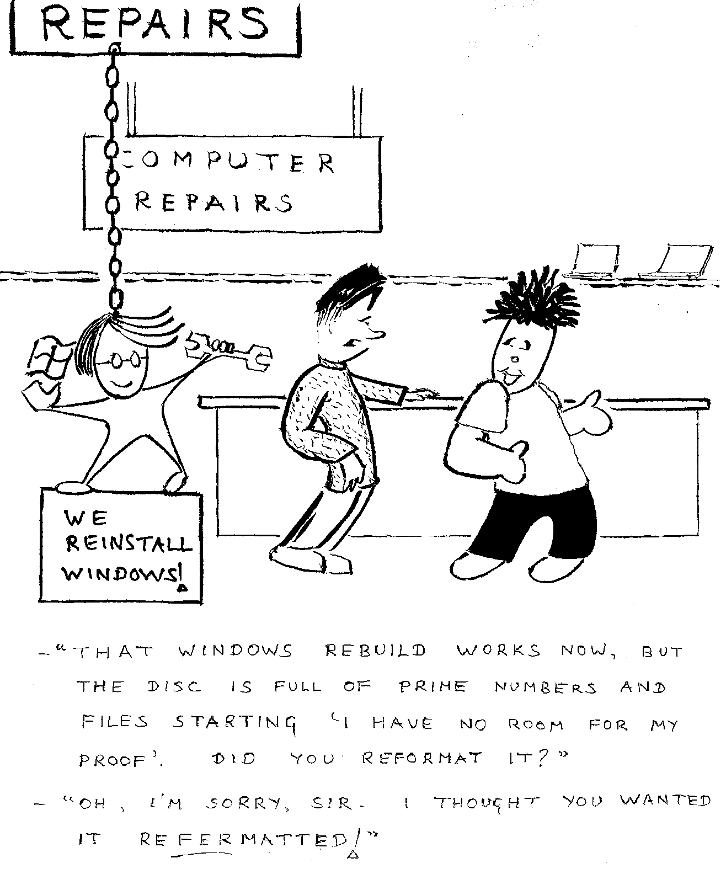

Drawn by TAB for TiBS
As well as cartoons, I’ve included a few essays from my blog. This is the first, in which I want to introduce you to the cartoonist pen-named TAB.
TAB has been drawing cartoons for over 30 years. What is unusual is that his cartoons illustrate research papers, in the journal Trends in Biochemical Sciences. They are detailed, often containing enough information about the metabolic pathway — or whatever is being illustrated — to make any verbal description of mechanism superfluous. Many are "naughty boy" tableaux that remind me of the Bash Street Kids.
You can see four of TAB's cartoons on the Web in an interview between him and TiBS General Editor Richard Reece, TAB of TiBS. This was originally published in the December 2006 issue of The Biochemist, and you can find it via the link in my online copy of this essay at www.j-paine.org/dobbs/tab.html . The final cartoon it shows was rejected by TiBS for being "too political"; it reads:
It took the eukaryotes 3,000 million years to evolve from the refuse heap — and just a few months of Reaganomics to undo it all again!
Why, in a computing blog, do I write about biochemistry cartoons? Because I would love to see TAB-style cartoons in computing research papers, program reference manuals, user guides. In his 1972 ACM Turing Lecture The Humble Programmer, the famous computer scientist Edsger Dijkstra remarked that computing is unique: our basic building block has a time grain of less than a microsecond, but our programs may run for hours. What other technology, he asks, spans such a range, a ratio of 10¹⁰ or more? When explaining such complication to our users, images are good. But please, not the tired old PowerPoint clip-metaphors that've been pasted in a million times before. Not the cogwheels and crowbar every documenter who has ever lived picks to symbolise adjustments to program settings. Make documentation fun!
There is more fun from TAB and other cartoonists in the book Sticky ends: an unrestricted collection of TIBS cartoons, edited by Steve Prentis, Elsevier, 1983. It’s out of print, though I once found a copy on Amazon; TiBS really should bring it back.
And perhaps TAB has drawn a Christmas cartoon (I wrote the original of this posting at Christmas). Elves will be transcribing DNA, sitting at the dashboard of a prominently-riveted steam-shovel while wearing hard hats. One elf will have lost his hat and knocked himself out, bashing his head on the methyl group of an overhanging thymine. Santa sits smugly, or snugly, in a soft recess of the cell membrane, couched in something spongy resembling bubblewrap. He laughs: "H₂O H₂O H₂O". He is dispensing presents to hopeful boys and girls. The boys and girls are genes; the presents are gene regulatory proteins, neatly wrapped in parcels that fit precisely to the gaps between their hands. Good boys receive repressor proteins that block gene activity. Bad boys don't. Their punishment for the year's naughtiness is to be expressed and made to toil on a treadmill for the following year, manufacturing the protein they code for. Behind them are sleigh riders. Instead of whipping their reindeer, they whip the boys to stop them slacking.
The sleigh riders are skilled drivers. You can tell because their sleighs carry no-el plates.

Problem Solved
I've been working with the Oxford Pain Research Group — that's "Pain" without an "e", no relation. I was analysing spreadsheet data about the effect of drugs on pain and sleep in large numbers of patients, and summarising it into measures of the drugs' clinical effectiveness.
Each spreadsheet contained several sets of data; and each set was similar in structure to the other sets, but not identical in structure to them. The differences were small, but irritating. So I coded a reporting function to summarise the most urgently-wanted set; and once we were satisfied with those results, wrote routines to transform the other sets so they had the same structure as this most urgently-wanted set. Thus I could get by with only one reporting function.
I could instead have coded different reporting functions for each set of data. Or I could have sweated away designing one function general enough to accommodate the differing structures of all the different sets. Every programmer will recognise such questions of design.
But why is the Universe so hostile to generalisation? It is so easy to copy and paste one chunk of code to give another chunk of code, and then hack the new chunk so it does something different from the first chunk. It is so difficult to edit the first chunk and parameterise it so that it does the second thing in addition to the first. Correctly.
I ask this because the quantum physicist David Deutsch has argued that the nature of computation is not a mathematical question, but a physical one. Mathematicians talk about “computable functions”: that minute subset, out of all functions possible within mathematics, that we can implement on a computer. Some say there is something mathematically special about them — a computational élan vital — that distinguishes them from all the other functions. That's wrong, says Deutsch. They are special because they happen to be instantiated by this Universe's laws of physics. The Universe is really really good at implementing addition; and therefore, addition is a computable function.
But generalisation isn't. And I, as a programmer, would really really like to live in a Universe where the fundamental processes that underlie note-taking and mark-making, whether in cuneiform on clay tablets, or Prolog in Pico, would implement generalisation as readily as this Universe implements addition. It would make programming so easy: always flowing downhill towards greater applicability and power, instead of towards greater accumulation of kludge, rot and cruft.
Anyway, in this Universe, my easiest route to finishing the pain-drug analysis was to build a machine that processed one set of data, then to build filters I could ram all the other sets through, forcing them into a form the machine would also accept. This used a lot of computer time; but computer time is cheap. And in explaining to my friend Sebastian Straube of the Pain Research Group, why I did things this way, I remembered the following joke:
How can you distinguish a mathematician from a physicist?
Lead them into the kitchen, give them each a kettle-full of cold water, and ask them to make a cup of tea. They will both boil the water, pour it into the tea-pot, and brew the tea.
Now give them each a kettle-full of hot water. The physicist will pour it into the tea-pot, then proceed as before. But the mathematician will empty the kettle down the sink, and fill it with cold water. This reduces the problem to one already solved.
It is a great shame that the Universe is not equipped with a built-in peephole optimiser. Had I implemented it, I would have included one as a service to all problem-solving creatures within my Creation.

Refer to Drawer
Here's a joke that has started doing the rounds.
A man walks into the bank and asks to see the manager.
"Excuse me," he says. "Your computer has sent me a letter saying there are insufficient funds to cover my cheque. Did it mean my funds, or the bank's funds?"

Coding With Dinosaurs
Computer language design is just like a stroll in the park. Jurassic Park, that is.
So said Perl creator Larry Wall. His words reminded me of a poem I read which has been knocking around my mind for many years:
He coded in Fortran like hell,
wrote programs with whistle and bell.
Now feels that this tool
has made him a fool
but cannot get rid of its spell.

Earth Falls Toward The Sun And Everybody Dies
Mars
is struck by a comet
and is visited by evil
aliens
who steal its reserves of
water
and
are stopped by a logician
who says 'I am lying'
and so he must be telling a falsehood
so he must be telling the truth
and so he must be telling a falsehood
so he must be telling the truth
(STACK OVERFLOW DURING RECURSION.)
This output is from a science-fiction plot generator I wrote in Excel. You can download it from www.j-paine.org/dobbs/sfgen.html .
Pestilence Goes Solo
I owe this one to a topic suggested by Dobbs blogger Mark Nelson's posting Comedy Central In My Spam Folder…
Stage lights dimmed, spots focused on four cloaked and hooded figures The drummer began a mental countdown. The guitarists hefted their axes. Centre-stage, the vocalist began to sing:
"Boils, buboes, and brucell—"
In an 'A' seat, somebody coughed. In a 'P' seat, somebody coughed.
The coughs became a chorus, a cacophony.
Eugenia Stubbs (15¾) shakily put down the packet of dolly mixtures her mum had given her for the long coach trip from Lower Styxborough. She was the Riders' youngest fan, and dreamt nightly of returning home hugging War's underpants to her cheek. But not tonight. She clutched at her stomach, groaned, bent over.
"Hurggh. Yaargh! GGGHKK!" Semi-digested egg and cress sandwich, apple, crisps, Fanta and dolly mixtures splattered between the seats.
The theatre café's pet cerberus, dozing beneath an autographed photo of Earthquake, Hurricane and Fire, whimpered. It began to vomit up a hairball; then stopped, its heads unable to agree which gullet to use. Frustrated, they growled and barked.
In the audience, boils popped like champagne corks.
* * * * * *
At a warped oaken table, of the kind found in every tavern in every square in every hamlet in every fantasy blockbuster pentalogy in Borders, sat three figures. The figure on the left fumbled for change.
"Damn cloaks," he muttered. "No pockets."
"NO POCKETS IN A SHROUD EITHER," observed his neighbour.
War fished out a handful of groats, three obols, and a denarius. He handed them to the figure on the right.
"Another round," he said. "And this time, make sure they're full."
Famine got up and carried the tankards to the bar. When he got back, the three quaffed deeply.
"Nice beer," said War. "Dry, but hoppy. Good backtaste."
"WE ARE NOT HERE TO DISCUSS BEER," observed his neighbour.
"He's got to go," said Famine.
"It's for the good of the band," said War.
"You can't hear the beat," said Famine.
"You can't hear the lyrics," said War.
"We'll have to sack him," said Famine.
* * * * * *
The Sun shone over a desolate plain. Two figures — one cloaked and hooded, one stooping under a sack of turnips — pored over a tattered A-Z of the Land of Mythological Personification.
"Egress of Eternal Exile?" muttered the farmer. "I haven't got my glasses. Um ... Turn left — Oh, not that one, that only gets you as far as the Portal of Perpetual Peril, then it's a dead end."
He turned the A-Z upside down, peered at the next page, peered at the previous page, fingered the index, hesitated, pointed.
"Got it. Two miles straight on, second on the left, over the humpback bridge of death, then past the turnip silo and it's just on your right. That way to the Egress."
Whereupon he coughed, turned blue, and sprawled in the dust wheezing. Two gryphons and a roc that had lost its way plummeted to the ground.
"Damn," noted Pestilence. "I always forget." He remounted his horse.
Fretfully, the Sun shone on. It seemed to have an unusual number of sunspots. Had it hands, it would have scratched.
* * * * * *
Dimensions twisted, space-time shifted. A jogger, pushing past bracken below the highest peak of Oxford's Shotover Hill, stopped. She was sure she'd heard a neigh. Or half a neigh.
* * * * * *
Pestilence kicked an empty Coke can into the path of a passing bus. Thanks to him, Britain had seen its most virulent ever epidemics of foot-and-mouth, bluetongue, and swine vesicular disease: worse even than in 2001. Then, the bovine death toll had stood at a mere 6 million.
But emergency legislation had closed the footpaths, making it impossible to view his work close up. Like all artists, Pestilence would happily spend hours browsing over past masterpieces. He just painted on a grander canvas than most.
And anyway, farm stock were no challenge after the exotica possible in the Land of Mythological Personification. He still cherished memories of phoenix spontaneous decombustion; neck-rot and head-drop in ornamental indoor hydra; and centaur irritable double-bowel syndrome. Not to mention his outbreak of obesity, complicated by diabetes and forced landings, in cherubim. Amusing, how the authorities had blamed that one on cherubic over-indulgence in ready-meals from cheap manna takeaways...
As for Britain's rabbits, stoats, shrews and voles — pah!
For a while, he had toyed with stiffhinge in Venus Flytraps and a satisfyingly large variety of wilt and root-rot possibilities inherent in cacti: his homeland had neither insectivorous plants nor xerophytes. But most indoor gardeners were quite capable of killing such plants without his help.
People, of course, were out. The multi-lingual cries and groans of plague-afflicted Egyptians, Hittites and ancient Greeks, Romans, mediaeval European peasants, were one thing. An Airbus dropping on your head or a reactor going critical as its operators collapsed was quite another. Besides, without people, how would he buy his guitar strings?
Pestilence mooched past a row of shops. Top Man, M&S, Dixons, Halifax, — . He halted, turned, nodded, smiled. It would be a lot of work. But he had lived a long time, and he had a long memory. Walking briskly now, he headed for the Job Centre.
* * * * * *
The Regius Professor of Historical Linguistics blinked at his inbox.
"It's a Rag Week prank, clearly," he said to the Senior Lecturer. "Some linguistics obsessive down in Computing."
"If you take it literally, then 'dek^', in an accepted transcription, is 'take'. Or 'get' or 'receive': there weren't many verbs back then. 'Nu': that's 'now'".
"But 'Nu Wiag^hróm dek^!'?" asked the Senior Lecturer. "That capital looks like a brand name. In Proto-Indo-European?"
* * * * * *
Halfway between Woodstock and Bladon, the Director of Y-Form Antigenics lolled in his chair, gazing idly at a sales graph that rose more steeply than the North Face of the Eiger. His gaze shifted, to the acres of manicured parkland, the Lake, the Column of Victory. He had always loved rural Oxfordshire. It had taken only a hint; whereupon David Cameron had discreetly kicked out the Duke and declared Blenheim a gift from a grateful nation, commemoration of a battle more important than any against the French. For without Y-Form, the Internet would have fallen long ago.
The Director's thoughts turned to business, and he began to muse about his employees. That programmer, the one with the predilection for black velvet ankle-length trenchcoats: somewhat Goth, or was it glam? The Director didn't know. But it wasn't the programmer's fantasy-game dress-style that mattered; it was his coding. Strange, mused the Director, how incredibly quickly he'd crafted his ingenious countermeasures against every new virus and spamstorm. It was almost as if he knew in advance which threat would come next...
* * * * * *
At the Heavenly Haystacks Rest Home, Lady Orsington-Smythe slit open an envelope and scanned the bank statement therein; then with a celebratory flourish, tossed a pork knuckle to her favourite labrador.
She had been worried about stabling the stranger's horse. He couldn't give her a pedigree; and he had regarded her in the oddest way when she had asked whether the horse had ever been exposed to contagious diseases. But it was worth it.Now she could afford to build that new stable wing for Heavenly Haystacks.
* * * * * *
The Regius Professor of Historical Linguistics beamed at his inbox. With the University's annual subscription to Y-Form Antigenics — to raise which, they had sold off the entire St Johns College wine cellar — 99.99% of spam was blocked by the new hyper-Bayesian filters. But the merest trickle, concocted somehow — no-one knew how — from languages now not much more than conjecture leaked through, as if to remind the world of the threat that could yet be. He started to decipher the Unicoded hieroglyphs:
Request for urgent business assistance.
I must solicit your strictest confidence in this transaction. It is, by virtue of its importance, utterly top secret.
We are son of Pharaoh, grandson of Sun God. By virtue of our position, we are invested with gold, electrum, and protective amulets equivalent to US$41,538,000.09. Owing to plague of frogs, we have urgent need to transport said goods in Nile barge from our country, and we ask your aid as willing partner in return for share of value and guarantee of immortal Godhood...
Engrossed, the Regius Professor read on.
* * * * * *
In WH Smith, the assistant handed over a pack of blank white A6 cards. "Keep the change," murmured Pestilence. Supply and demand; demand and supply: that was the secret. His future secure, he sauntered towards the first newsagents with an advert board in its window.
"VOCALIST SEEKS BAND," he wrote. "My influences are ..."
It was time to get back on the scene.

Ο Μαθητής Μαθαίνει το Μαθηματικά; or: You Say Math, I Say Maths
Mark Nelson provoked this essay too. In a posting about The Princeton Companion to Mathematics, he referred to "that vanishingly small group: people who actually like math. (Or maths, as Jocelyn might say.)" But why do Americans say math while I say maths? I tried looking this up, but didn't find anything useful. Not even in the Oxford English Dictionary. Though one posting did inform me that Americans make math singular because "they can only work on one problem at a time". Probably, its author was not American. Nevertheless, I do have a soft spot for the question, because of a mistake I once made in Athens. So I'll tell you about that instead.
In the 1990s, I spent several visits to Athens working for a software company. Athens may have been cleaned up since, but then, it was notorious as the dirtiest capital in Europe. The sort of place you find half a dead dog on every street.
Despite this, Athenian mornings were so wonderful. There was SUN! (I'm English.) Sitting outside a café for breakfast eating honey and sheep yoghurt from battered tin dishes while ticket sellers wandered past with strings of lottery tickets hanging from poles. Walking up the exit steps from the dimness of the Metro station, the sunlight and the noise and grime of Omonia Square expanding before me. I would become equally aware of both, but the sunlight was so intense, and made me feel so joyful, that the noise and grime didn't matter. When I returned to Oxford, even on a sunny afternoon I could see the darkness behind every patch of light.
I had learnt some Greek before my first visit, but it's always good to know more. I've gained a lot by learning enough of the languages of countries I've visited to be able to understand at least some of the lyrics of their music. Be it Sérgio Godinho in Portugal, Manos Hadjidakis in Greece, or Hubert von Goisern und die Alpinkatzen from Austria: "Alpenrock" music, like the Bonzo Dog Doo-Dah Band but with accordions and yodelling. (I do recommend a lovely sad-sweet song they do called Weit, weit weg. It's on YouTube.)
Besides, for part of these visits, I was living in a hotel which was full of models! I'd chosen it because it was one of the few buildings in Athens that didn't have traffic running past all four sides; and after I'd booked in, I discovered it was where Ford Models sent their people for shoots. This explained why, when the hotel's owner had shown me round the hotel common room and communal kitchen — not many hotels have a residents' kitchen, but this one did — everyone looked so healthy. Actually, as I booked in, a girl happened to walk out of the lift towards me. "You mustn't mind that we're all so beautiful" she said, "because, you know, we're models."
The models were mostly female and American. Though at their Thanksgiving party, I met a man who had spent five years at Hewlett-Packard, got fed up with office life, made himself a portfolio, and become a male model: the kind of slightly-better-looking-than-average Mr. Average who appears in ads for razors, exfoliators, and men's handmade natural soap. He explained to me how frustrating life was for the models. Their favourite recreations were eating, drinking, and staying up late in nightclubs. Self-defeating if you want to keep your looks.
The models couldn't amuse themselves by reading or chatting to the locals, because none of them had learned Greek. They invited me to a restaurant one night — really, a small café with a big takeaway counter and lots of chicken and fish on display in the window. The only way they managed to order was by pointing.
So learning more Greek was definitely indicated; which is where I needed the energy given me by the Athenian sun. Because I noticed an advert for intensive Greek courses run, for not-quite-beginners, by the Hellenic American Union. I wandered round to their office one night and took a preliminary test: a sheet of paper headed Σωστό ί λάθος — Right or wrong — on which I had to tick or cross against twenty sentences for errors in vocabulary and grammar. This deemed me a not-quite-beginner, and I booked a course.
When I say "intensive", I mean it. The course was three hours a day, every weekday. Except November 17th. In 1973, there had been a famous protest against the Junta, which the local anarchists celebrated every year. There would be a motor-cycle roar-past and some mild firebombing, and it was a good idea not to be in any building with an American flag outside it. So on that day, the Hellenic American Union closed.
Every other weekday, the course ran. So I arranged with the software company to attend the course between 9 am and noon, and then work between 12:30 to 8:30 pm. This was tiring.
But useful — because you need a lot of practice.You can know the grammar intellectually, but still not be able to execute it fast enough to keep up with a conversation.
The trouble is that Greek is highly inflected. For example, nouns have four cases: nominative, accusative, genitive, and vocative. The ending of a noun changes to indicate its case. So the dog sees the dog of the dog becomes ο σκύλος βλέπει το σκύλο του σκύλου. The σκύλος is the dog doing the seeing: nominative. The σκύλο is the one being seen: accusative. And the σκύλου is the one owning the one being seen: genitive. The word before each dog means the, and changes in order to agree with the noun. Which happens also with adjectives and some numbers.
In fact, there are three genders of noun, and the endings depend on the gender. Worse, each gender has several patterns of inflection — declensions — and the endings depend on this too. The only ending that is the same for all nouns (as far as I remember) is that for the genitive plural, -ών. So wandering round the streets of Athens after work or at the weekend, practising grammar from my Hugo Greek in Three Months or my Levend Grieks: een praktische cursus (I'd come from Eindhoven, one time), I was always really pleased when I came across a genitive plural to memorise or translate. It was like learning a particularly irregular set of Unix commands, and feeling relief that at least when you wanted to read a file, they all used a -f option.
By the way, if you've read Winston Churchill's My Early Life, you may remember his disgust at discovering he had to learn a Latin ending especially to say O table! Why would Romans talk to tables? But he'd have done the same in Greek: that's what the vocative is for. When my friend Petros's mum calls him down to dinner for a χωριάτικη σαλάτα — it means country salad, and is what we call a Greek salad — and a glass of retsina, she shouts not Πέτρος! but Πέτρε!
Verbs in Greek are as troublesome as nouns. Firstly, they change to indicate aspect: whether the action is being done once or repeatedly. I pay — present tense — is πληρώνω. And the particle that makes a future tense is θα. But if you simply glue the two together and say θα πληρώνω, it means I will keep on paying. The waiter would be ecstatic; but what you actually must say is θα πληρώσω. The ν changes to σ, indicating once-only payment. Though some financial situations do require the continuous-time aspect. Such as translating the economy will be in recession.
Related changes happen when you make a past tense. Moreover, some verbs add a prefix or change the syllable where the stress is. And some use completely different words, as with English go and went. I write, I wrote is γράφω, έγραψα. I cut present and past is κόβω, έκοψα. I leave, I left is φεύγω, έφυγα. I eat, I ate is τρώω, έφαγα. I see, I saw is βλέπω, είδα. (You would recognise the last two in the words bacteriophage and eidetic.)
In addition to these, you need to remember the ending for each person: I see is βλέπω but he sees is βλέπει. There was a large and very well-known meat factory which had advertising boards erected all round Athens. These showed a sausage and the slogan βλέπεις Νίκας ε.ναι καλό! I think this means you see Nikas is good!, Nikas being the meat factory's notional owner, and καλό being good. Though I may have misunderstood, because as I've explained it, it's dire advertising.
At any rate, -ω -εις -ει are the personal endings you must learn for I, familiar you, and he, she, or it. Not to mention that there's another conjugation of verbs which has different endings, and that others are different again because though they have an active meaning, you write them as though they were passive. An example is κοιμάμαι which means I sleep. Unlike the I verbs above, it doesn't end in -ω. There's a saying, probably from scholars of ancient Greek: every verb is an enemy. Actually, Modern Greek has only one regular verb.
Such complexity isn't unusual for an Indo-European language. Travel overland, and you'll discover that Romanian and Bulgarian have their own intricacies. But as I said, it does mean you need lots of practice. In inflections, and in idioms. For example, there's an idiom for saying you like, or are pleased with, something. Μου αρέσει Χιου Γκραντ means I like Hugh Grant. We were drilled in this again and again, having to think of an actor, a food, a film, ... and tell the teacher we liked it. And hence we ended up able to call up the phrase immediately, without having to consciously translate it. (And note that translating word for word, as novice language-learners sometimes try, often doesn't work.)
To keep us alert, the teacher would ask ten or so questions, each time picking a different member of the class at random. If they got the answer wrong, she corrected it and had us all chant the correct answer. This meant that the last thing heard would not be a mistake.
During one session on verbs, the teacher asked me what I'd learned. Έμαθαινα... I replied, wrongly forming the past tense of μάθω, I learn. Wrongly, because the verb is irregular and the correct past is Έμαθα. It was a trivial mistake, but I’m English, so embarrassment is the main constituent of my psyche. And there's psychological evidence that we remember bad events better than good, presumably as a survival mechanism to stop us repeating mistakes. So I'm not surprised that I still remember this.
But I remember it also because of the honourable place occupied by the verb μάθω. According to the Oxford English Dictionary, the French and English use of the plural mathematics, known from the 16th century, seems to have originated as an elliptic expression for mathematic sciences. That adjective mathematic, also first recorded in the 16th century, is adapted from French mathématiques or its Latin source mathēmaticus. This in turn is adapted from the Greek μαθηματικώς, formed from μαθηματ-, μάθημα, something learned or science. Which is from a root of μανθάνειν. Which is learn in ancient Greek.
But I still don't know why Americans shorten it to math.

Why I Want to be Transhuman
This essay was inspired, in part, by mathematical physicist John Baez posting to a maths blog I read. He was writing about SF author Greg Egan and the things that are really worth doing. The online copy of this essay at www.j-paine.org/dobbs/transxmas.html links to his posting and the other topics link-formatted here.
I want to point you at three of my favourite songs. They are: Македонско девојче; O δρόμος; and Πάμε μια βόλτα στο φεγγάρι. The first is a Macedonian folk song, also Bulgarian; the second is Greek, by Manos Loizos; the third is also Greek, by Manos Xatzidakis. All are YouTube links, though I'm sure pasting the titles into Google will find other versions too; and I think you'll enjoy the music even if you don't understand the words. The third song is incredibly nostalgic.
I have a friend called Jon Franklin who likes sad music: haunting, plaintive, yearning. I like it very much too, which is why I am so pleased I have these three songs. I don't recall where I found the first: probably at a Balkan dancing class. The second: after being told of Manos Loizos by a Greek who was at my college and who became a local-radio DJ in Greece. (Giannis, I can't remember your surname, but do get in touch if you should ever read this.) The third: on a tape my friend Petros Stefaneas bought me while I was living in Athens.
And because Jon would like the songs too, I emailed him last night. I was in Oxford's pub Far From the Madding Crowd. I pulled my laptop out of my rucsac; I booted it and connected to the pub's free Wi-Fi. I called up Firefox; I typed English transliterations of the song names into Google. I plugged in my headphones and decided which of the resulting YouTube tracks I liked most; and then I logged into my Internet Service Provider and emailed the URLs to Jon. Last century, I would have gone home to make a compilation tape.
Now let me take you somewhere very different: to one page of the n-category Café blog. The page in question is a thread about Greg Egan's latest science-fiction novel Incandescence. And this posting in it is a comment about Incandescence from mathematical physicist John Baez:
Indeed, one nice thing about certain SF stories — like Riding the Crocodile, or some other things by Egan, or parts of Kim Stanley Robinson’s Mars trilogy, or some of Iain M. Banks’ Culture novels — is that they tackle the problems faced by people whose basic needs are all met, and who thus need to tackle the question what’s really worth doing, when you have the freedom to try anything?
A lot of non-SF writing — so-called 'serious literature' — features characters faced with this question who collapse into self-destructive behavior. This is an important problem, but ultimately I find it a bit boring. Yes, you can become a drug addict, kill someone, or slit your wrists…. next?
One thing really worth doing is glorying in the ideas of mathematics, the structures of physics and chemistry, the wonders created by evolution. Take a look at the pollination mechanism of the bucket orchid, explained by Eric Hansen in Bee Bop. Each flower of this remarkable plant is like a bucket. A bee comes to it, attracted to the scent; falls into the bucket, which is filled with fluid; and tries to climb out. But the only way out is through a narrow tunnel, and from its roof, twin pollen sacs hang. The bee bumps into them, and they break off. Each sac has a sticky base, but the glue takes some time to set, so the flower keeps the bee trapped until it has. He can then escape, perhaps 45 minutes later, with the packets sticking to his back. Eventually, the bee will fly into a female flower. And this time, he will blunder against a bump on the roof that knocks the pollen packets from his back and pushes them onto the flower's pistil, pollinating it.
John Baez glories in these marvels too. And he is a top-notch explainer and enthusiastic science populariser, which is why he writes a weekly column called This Week's Finds in Mathematical Physics. Had I the time, which I don't, because I've got to fix yet another Web server — and when will our machines eliminate the necessity of work? — I would spend my entire time absorbing and explaining such marvels: bucket orchids, pore-size regulation in E. coli, the subtlety of isomorphism and equality, Stelarc's third hand, Neural Gases, the duality between Geometry and Algebra or Space and Quantity. Because helping others understand the marvels is a second thing really worth doing. (And why not draw cartoons of them…?)
I get joy from this because it reawakens what science-fiction readers call the Sense of Wonder. But a third thing that is really worth doing delivers a different joy: that of luxuriating in the sensuality of art. When I travel, I collect local music. I send myself books on icons, on the Byzantine town of Nesebar, on delicate Russian lacquer boxes from Kholui. A book by Portuguese Miguel Torga, with his story O Cavaquinho: destitute father in a remote mountain village can barely afford to buy his son the first Christmas present ever, a cavaquinho guitar; trudges miles through ice and snow to the city market; is found dead not far from home, guitar fallen in the snow beside sprawled body. A book by Bulgarian Aleko Konstantinov, whose yobbish anti-hero Bai Ganyo sweats and farts around Europe with bumpkinish lager-lout manners inherited from a Bulgaria only just out from under the Ottoman Yoke.
And I have cartoons by Argentinian Quino, who draws a Peanuts-ish (but darker) strip called Mafalda, and single cartoons whose characters are usually being tormented by bureaucrats and dictators. Cartoons by Belgian André Franquin, whose infeasibly creative office-boy Guust Flater invents really silly things like a plastic duct slung above office desks to give his goldfish room to swim. Guust is great fun: I don't think he's been translated into English, so I read him in Dutch. I don't think Quino has been translated either, although I have copies in French, Greek, Italian, Portuguese, and Spanish.
Which brings me back to my first paragraph. There are too many languages to learn. And Google Language Tools is not yet adequate for literature. Though it is already amazing. Remember those old science-fiction clichés? "He threw the mechanical translator into gear and began negotiating with the alien ambassador." And now we have the translator: free, and available from any rural pub equipped with a Wi-Fi box.
In this particular pub, I'm just going to buy another half of Bingle Jells, a strong bitter brewed by Mighty Oak. Some beers are dry and taste of ginger; others are heavy, and taste on the sides and back of the tongue like alcoholic Frank Cooper's Thick Cut Oxford Marmalade. Were I in Braga in Portugal, I would eat a slice of strong, dry, artesanal queijo de cabra, balanced by a strong red wine from Estramadura. (Lots of tannins, I like, the rougher the better. I have peasant tastes, me.)
In Athens, Taverna Barbagiannis — in Odos Emmanuel Benaki, I think — did an excellent red onion, dill and potato salad, which I have given a recipe for here, if you search for the string "Greek Onion, Dill and Potato Salad". (I collect recipes too.) It is excellent to sit in the warm Autumn air, tasting the freshness of the dill against the heaviness of the potato, somehow moderated by the salt of the olives and the biting pinpricks of grated red onion.
It is also excellent to walk down Odos Kallidromiou on Saturday morning, smelling the bunches of dill on the market stalls and deciding which to buy from aroma alone. And it was excellent to live in Hotel Orion above Odos Kallidromiou, because most residents were working for Ford Models. As I booked in at the hotel, not knowing this, a girl happened to walk out of the lift towards me. "You mustn't mind that we're all so beautiful," she said, "because, you know, we're models."
Cooking; wine and beer; personal beauty: these are art too. But let me interrupt myself. In 2006, I published links and quotes in the Dr Dobbs AI Expert Newsletter, to illustrate the diversity of AI over its past 50 years. One link was to a quote by Marvin Minsky from It's 2001. Where Is HAL?, transcript of a 23rd May Dr Dobbs TechNetCast for Game Developers Conference 2001, previewing Minsky's book The Emotion Machine. Unfortunately, the part of the link that carried Minsky's quote has died, so I'll reproduce it below:
I was once giving some lectures on longevity and immortality. I noticed that people didn't like the idea much, so I actually took a poll of a couple of audiences. I asked how many of you would like to live for 200 years. Almost no one raised their hand. They said because you'd be so crippled and arthritic and amnesiac that it would be no fun. So I changed the question. How would you like to live 200 or 500 years in the same physical condition that you were at half your age. Guess what, almost nobody raised their hand. But when I tried the same question with a technical audience, scientific people, they all raised their hand. So I did ask both groups. The ordinary people, if you'll pardon the stereotype, generally said that they thought human lifetime was just fine. They'd done most of the things they wanted to do. Maybe they wanted to visit the Buddhist statues in Afghanistan, but they could live without that. And surely another 100 years would be terribly boring.
A fourth thing really worth doing is appreciating abstract structure: in art, in mathematics, in humour. I have a notion that, high in the brain's abstraction hierarchy, some mathematics activates the same neurons as do — for example — El Lissitzky posters and De Stijl typography. I base this only on introspection, though I'm willing to donate the idea to anyone with a spare fMRI scanner: looking at such images feels remarkably similar to when I try to visualise the contents of certain category-theory papers. Particularly, for some reason, those by William Lawvere, in which he describes such wonderful constructs as the "adjoint cylinder" and the "adequacy comonad". The latter, actually, feels as though it resembles H. G. Wells's time machine. The small one, that sat on an octagonal table and was used as a model: an intricate little gadget, all levers and gleaming quartz and brass and nickel bars. At any rate, I derive joy from sitting back and contemplating mathematical structures. Not hacking out proofs, or "doing" anything in particular, but just "looking" at them. This is mathematics as sculpture.
This Dobbs posting is more personal than most of mine. Compared with much writing about transhumanism, it seems the best way to make my point. So I shall note that it is now the following morning, and I am sitting in my local Costa, enjoying a cappuccino while awash in the oceanic melodies of Existir, an album by Portuguese band Madredeus. I just finished listening to an anti-Salazar song, O Charlatão, by José Mário Branco and Sérgio Godinho. I like Godinho's nifty wordplay so much that I'm going to ask Windows Media Player to play it again.
But Portuguese is yet another language to learn. Well, the caffeine in my cappuccino is a cognition-enhancing drug. So, I suspect, is Madredeus. I do hope, though, that the pharmacologists quickly invent something better. Caffeine kills sleep, and if we went round all day playing Madredeus on our iPods, it would be distracting. But we do need something, because our brains are so remarkably ill-tuned to the amount of practice needed to learn anything that's really worth doing. Just count the second-hand Greek and Spanish grammars, the guitar-chord tutors, in your local Oxfam. Almost unused: one lesson, and then the brain stops wanting to learn. If there are neurophysiologists reading this, please tell me: what on Earth is the evolutionary benefit of not wanting to improve a skill?
So we're stuck with brains designed to count the bananas. And then we die. To Minsky's audience, that didn't matter. But it does to me. I want to live forever, to continue doing things that I love, that are really worth doing. Read Nick Bostrom's The Fable of the Dragon-Tyrant, and tell me. All the money wasted on the bloody Iraq war: wouldn't it have been better spent on anti-senescence research? Bostrom's fable is about the immorality of not researching immortality.
And, I want to do the things really worth doing with a brain that wants wholeheartedly to do them. And I want to do more. In 2002, I went round Europe to watch the Euro come in. I stopped at a Maastricht beer festival, and met a man who was a beer-recipe consultant. He would taste a brewery's beers, and then suggest new recipes that would fill gaps in their product range. In order better to do so, he had gone to London and had surgery to improve his taste discrimination. Technology to enhance his body.
Oh, you say, I've tagged this posting as "transhumanism" but haven't explained what that is? Transhumanism is using technology to enhance our bodies and minds. Like my brewery consultant. Like I was doing in Far From the Madding Crowd when I Wi-Fi'd, Googled, headphoned, and emailed. But more so. Exponentially more so; but always to deepen the kinds of joy that I've catalogued above; and others that I haven't. I want this so much. I yearn for it. As strongly as the singer of Πάμε μια βόλτα στο φεγγάρι yearned for the moon.

Listless
Lisp looped past initial CAR,
thence CADR and CADADDR.
I didn't check for NIL; and so,
Lisp looped on listlessly.
I was trying to imitate this ancient rhyme:
Ruth rode on my cycle car
directly back of me;
I hit a bump at sixty-five
and rode on ruthlessly.
(In Lisp, as often elsewhere, lists are sequences of storage blocks. Each block has a head, holding data, and a tail, pointing to the next block. But the head is called CAR and the tail CDR, after ancient abbreviations used on the IBM 704 where Lisp was first implemented. CAR stands for "contents of address part of register"; CDR for "contents of decrement part of register". Functions named after combinations of A and D were and still are provided: for example, CADR gets the head of the tail of a list.)

Central Dogma
Oh, DNA makes RNA,
and RNA makes protein;
Prions make protein too,
Mad go ewe.
To be sung to the tune of Mares eat oats.

Bitter End
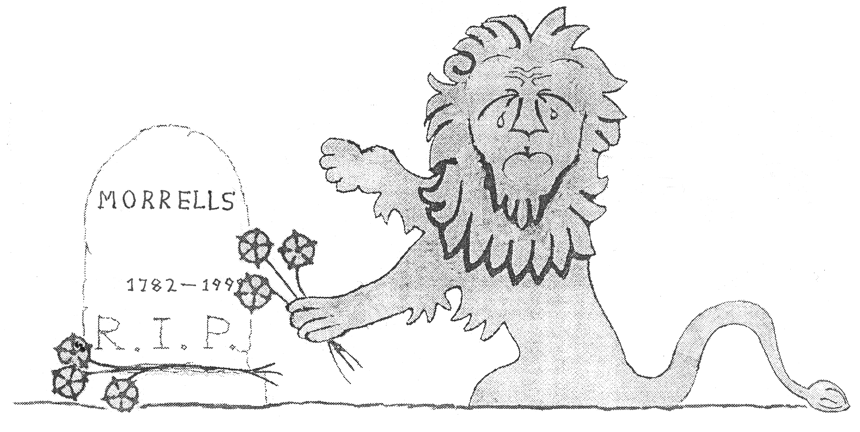
The cartoons following are not about computing. This one commemorates Oxford’s Morrells brewery. I used to enjoy Morrells’s academically-named beers — Varsity, Graduate, Proctor, College Winter Ale. But in 1998, the brewery closed after a board-room bust-up which ended with the managing director Charles Eld being escorted from the building. He wanted to modernise and brew more beer; but from the fact that the brewery is now eye-wateringly expensive flats, it would seem his colleagues saw their future in property. The design above is my variation on the Morrells lion, normally seen with a jauntier tail.

Alien Imperative
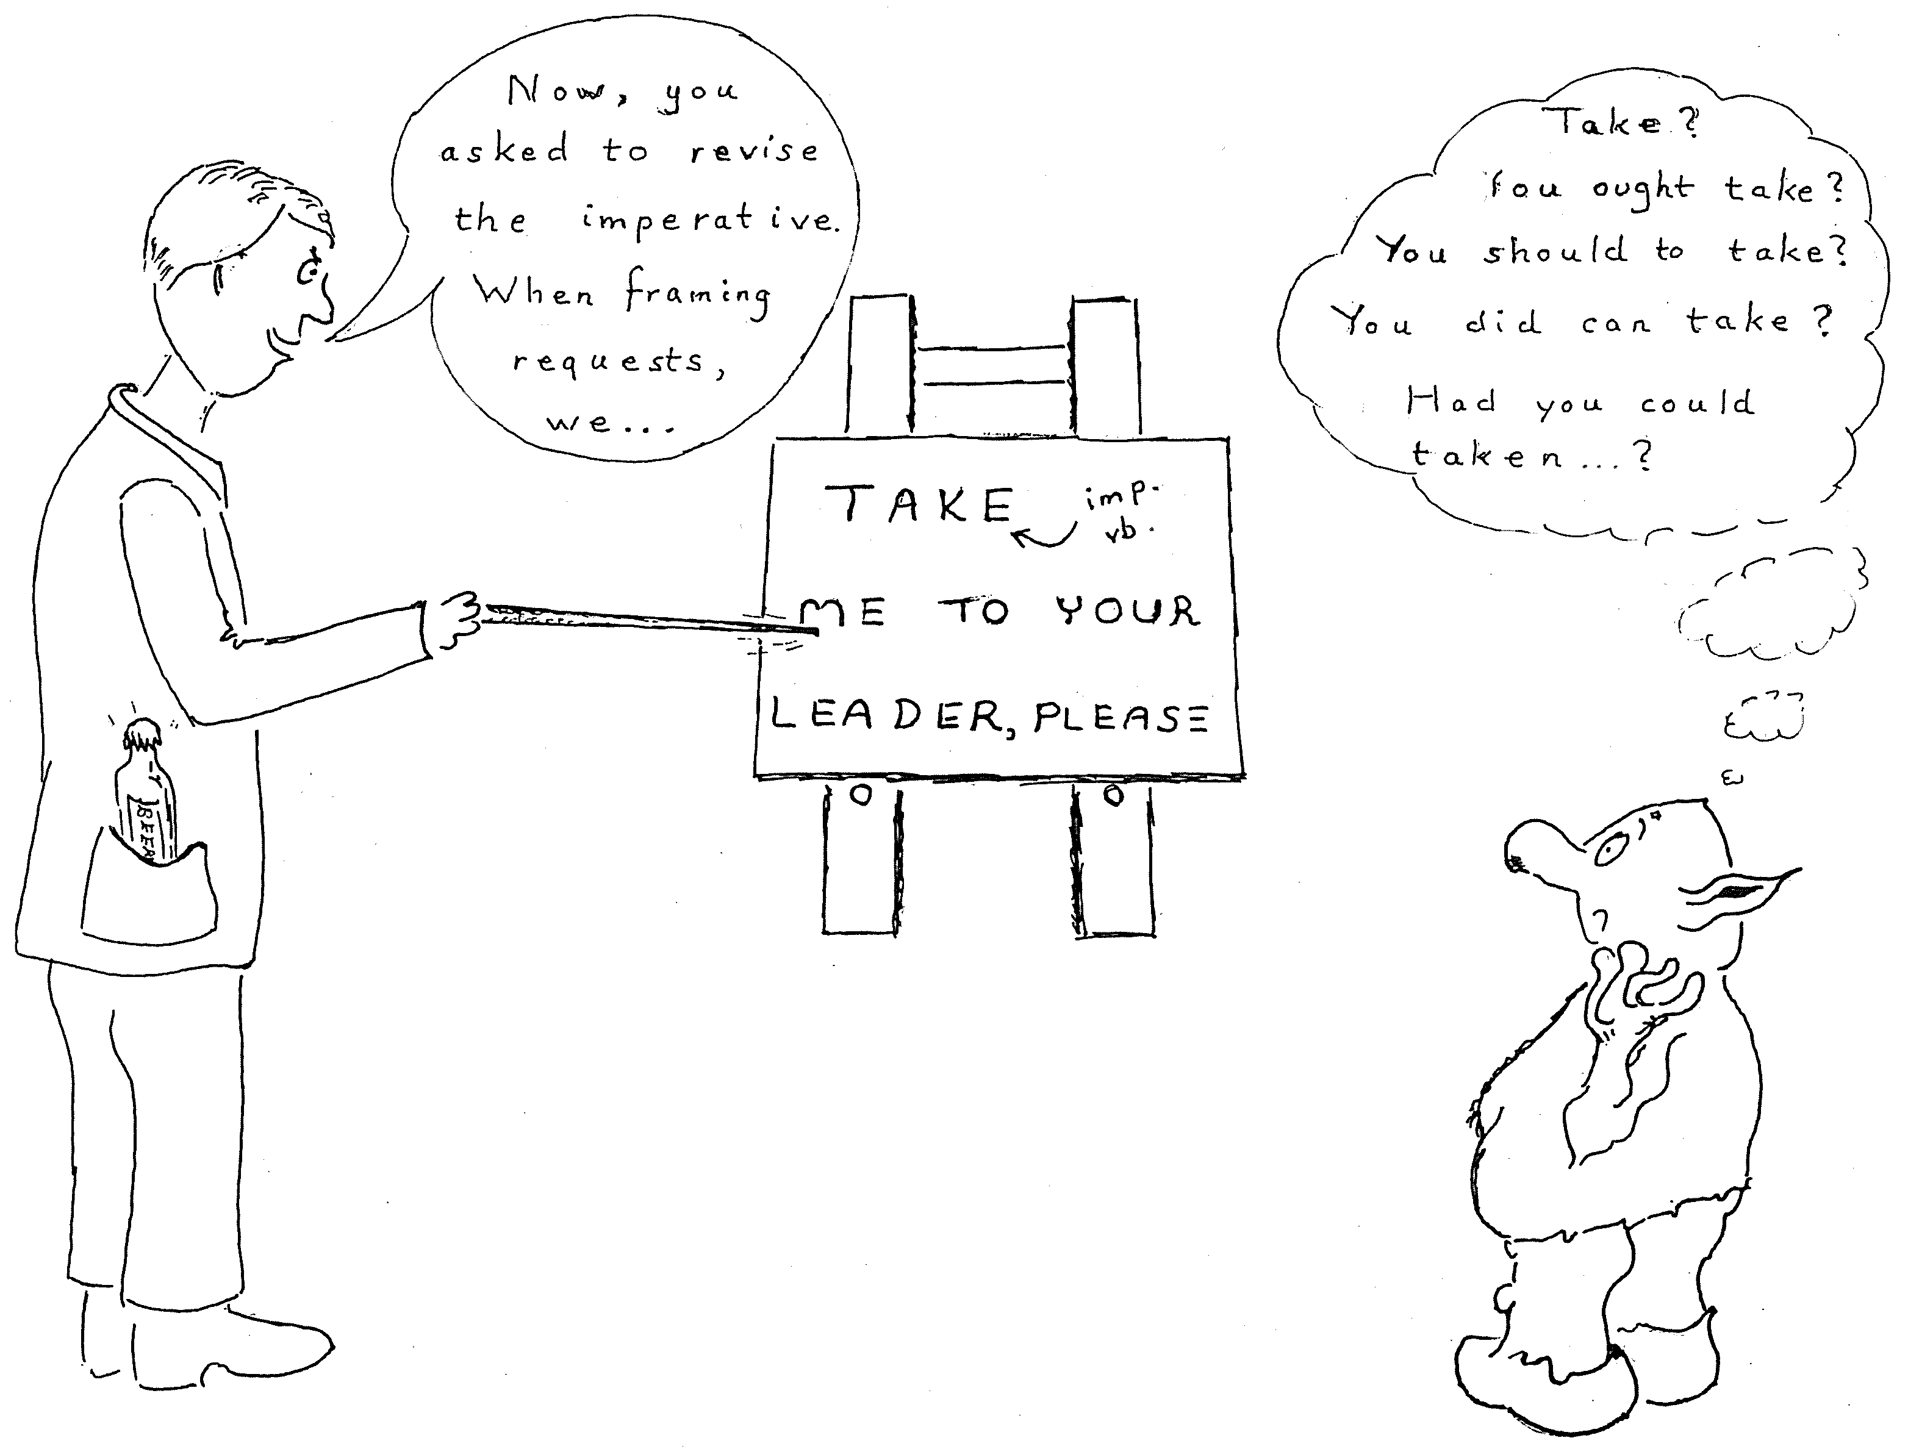
Inspired by Oxford’s many language schools.

Lest it isn’t obvious, the next two cartoons are spoof adverts. One is fairly old, and I suppose I ought to update the list of countries…
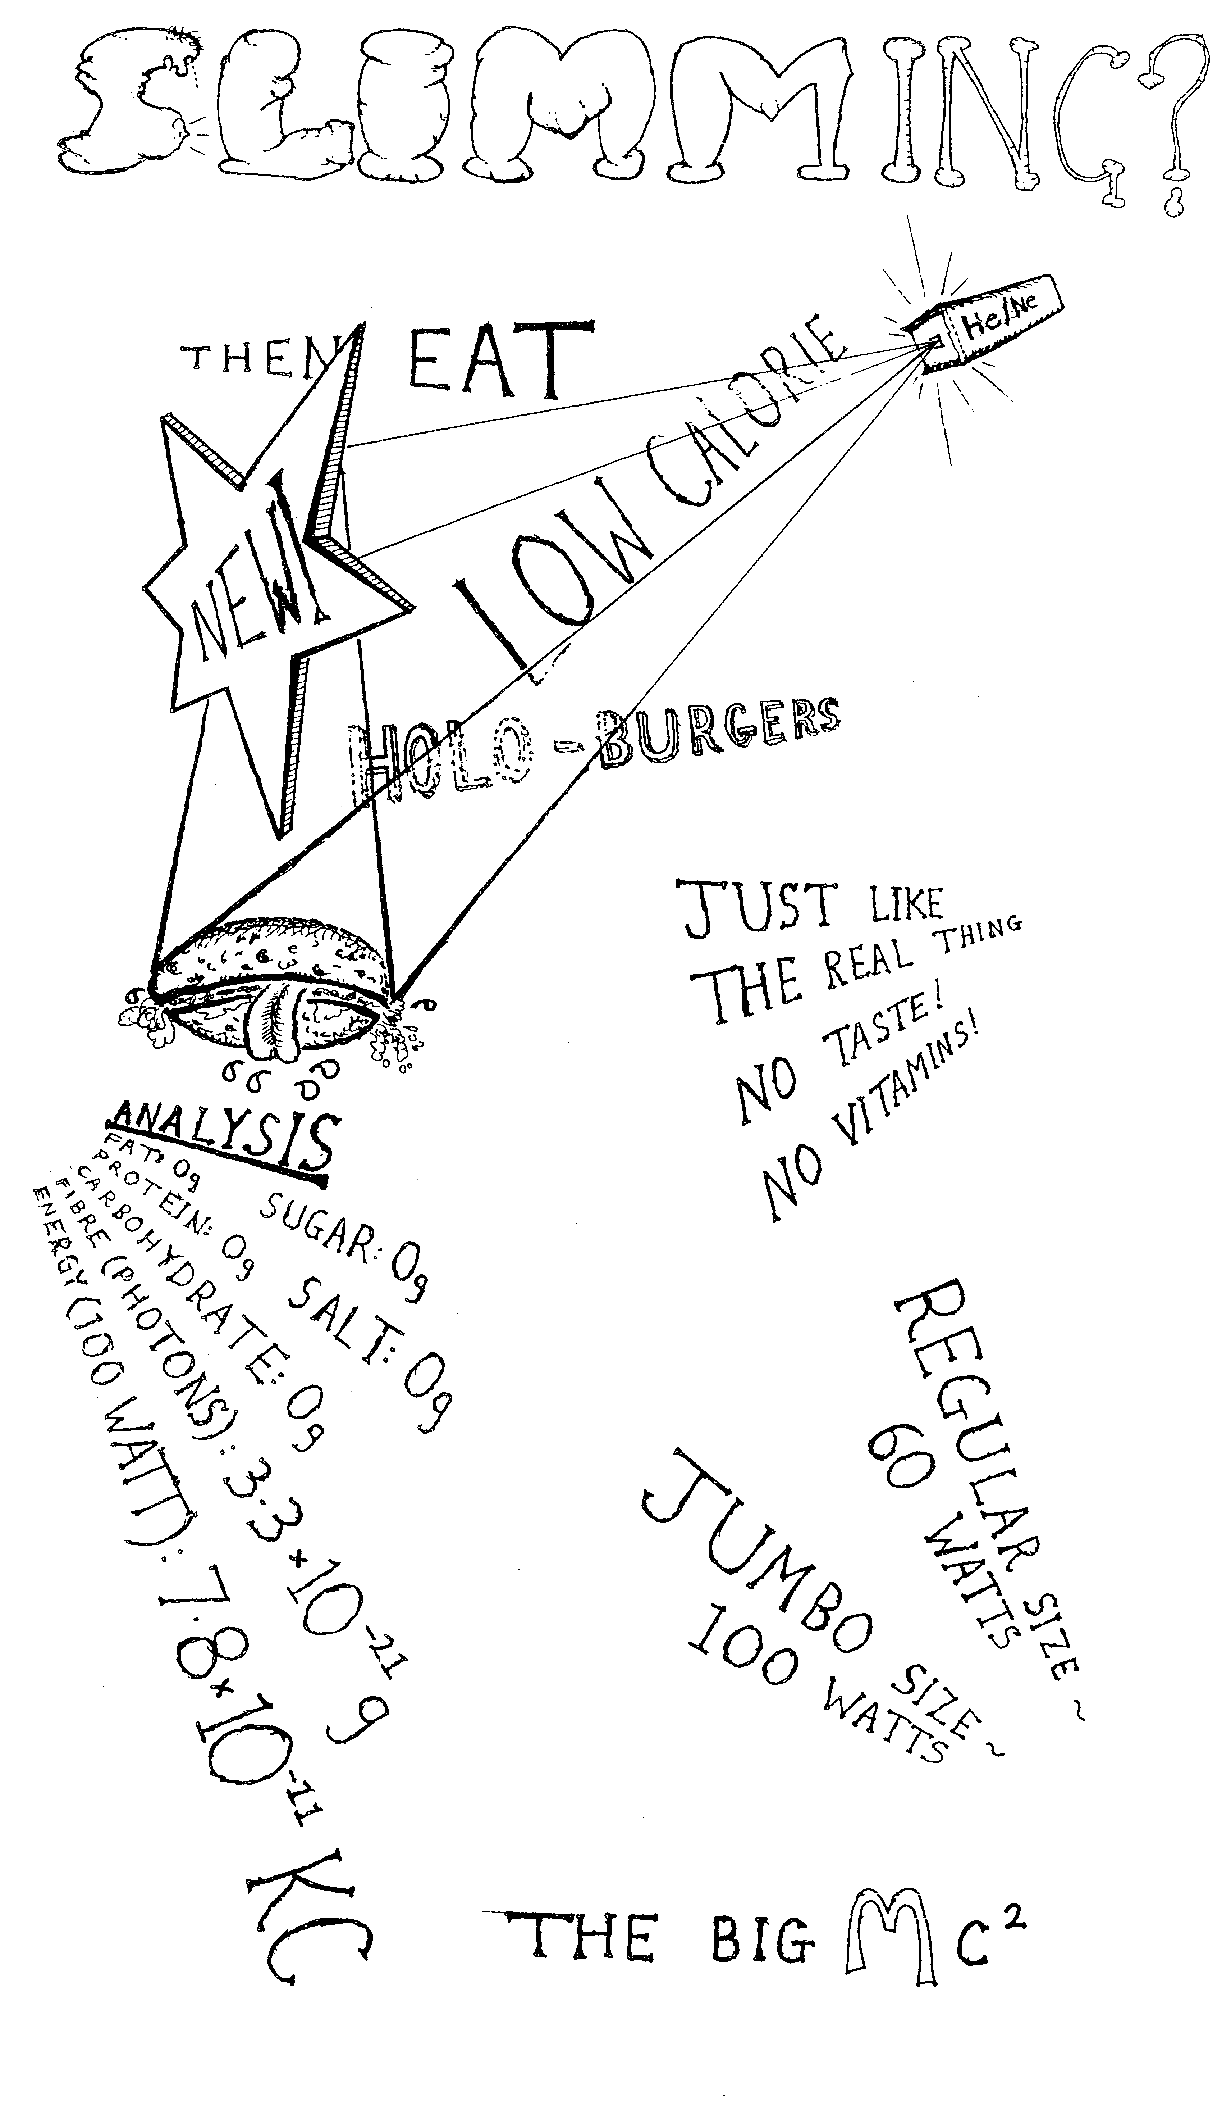
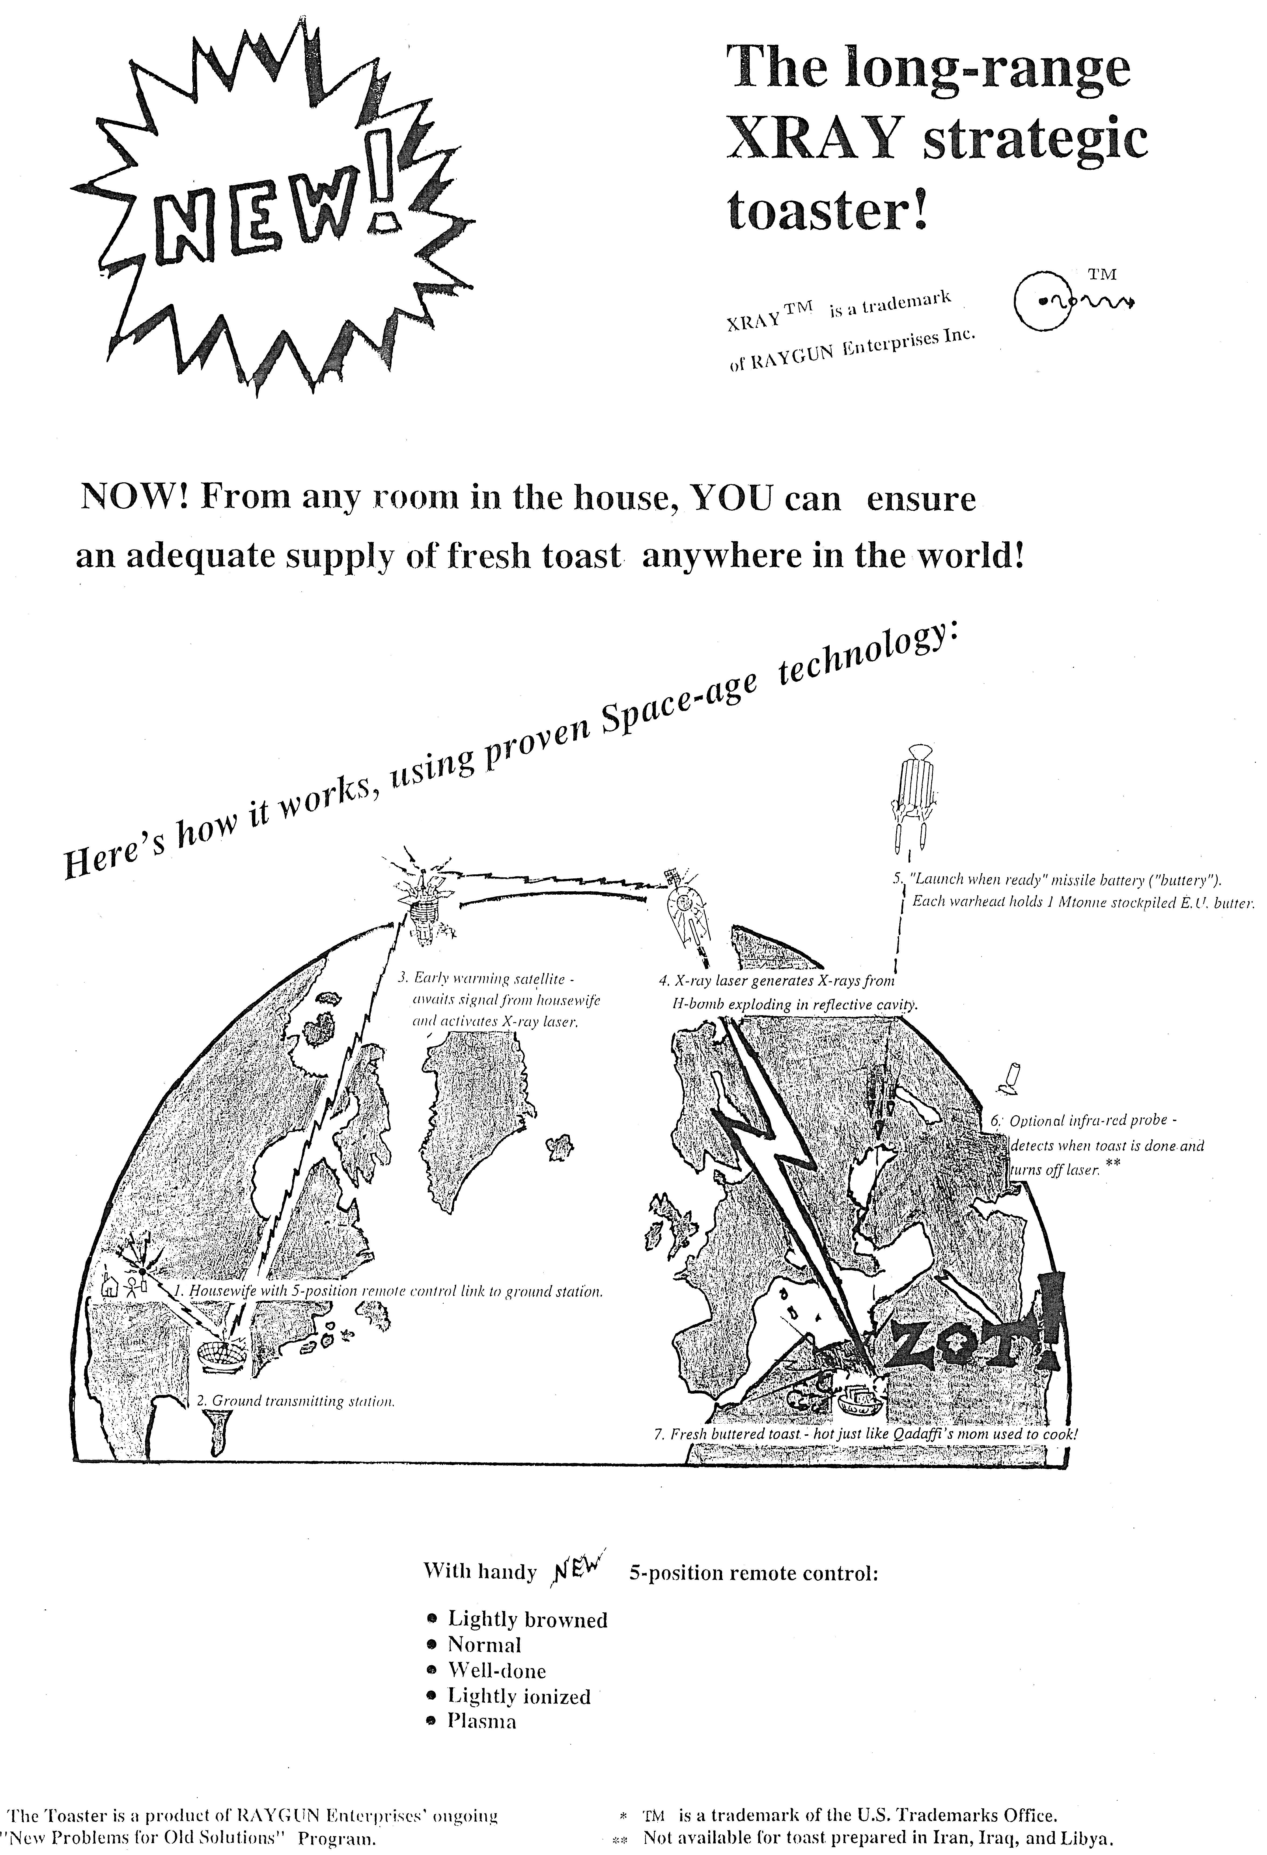
A Plea to the Future
At the start of every October, in 0th Week and the Examination Schools, old students tie, glue, Blu-Tack and pin: insecurely adhesing bamboo canes, A1 card, and society posters to Exam School desks for the enticement of new students. One clambers onto a desk and picks frantically at the end of a reel of Sellotape; another scoots past with 500 termcards fresh from the photocopying shop across the road. Everybody disputes the ownership of scissors.
The Oxford Union; Cherwell; Experimental Theatre; CompSoc, whose display seems to be obsessed with little plastic penguins; the Wine Appreciation Society and the Banana Appreciation Society. Who, one year, some wag of an organiser placed next to each other. The Banana Appreciation Society had a 6 foot plastic yellow banana rearing from its desk. The Wine Appreciation Society did not have a huge plastic grape.
On one desk, a signed photo of William Hague; on another, a portrait of Marx. But on ours, a hardback Emperor's New Mind in its striking blue cover; the opening pages of John Varley's Overdrawn at the Memory Bank and Vernor Vinge's True Names; a DVD of The Matrix. A photocopied conversation with Eliza; a proof in Prolog that if John drinks wine, then Mary loves John; an essay, inspired by Searle's Chinese Room and Douglas Hofstadter's A conversation with Einstein's Brain, on what it feels like to be America. A poster announcing that Why Robots Will Feel Emotion would be the next talk given to the AI Society.
I was AI Society President.
As well as promoting AI, I taught AI to Oxford psychologists. But that stopped, because the people who chose the degree courses decided AI was irrelevant to psychology. There was no tradition of AI; and Oxford can be very traditional. In 1994, I spotted a Computing Service poster for a course about the Web. "Shall you teach us to write Web pages?" I asked. "No," answered the tutor. "Only to read them. You won't need to write them." Thinking of an acquaintance who was doing a DPhil on the nature of personal identity after resurrection to Heaven — a lovely person and a dedicated scholar, but a futile topic, for if God exists, we shall discover the answer empirically, and if He doesn't, the effort would be better spent on cancer research — I felt my subject would be better accepted were I teaching theology.
But one day, AI will be theology. Listen to Frederic Brown:
Dwar Ev ceremoniously soldered the final connection with gold. The connection that would link all the computing machines of all the ninety-six billion populated planets into one universe-wide supercomputer.
"I shall ask it a question," said Dwar Reyn, "which no single computer has been able to answer. Is there a God?"
"Yes," thundered the machine's mighty voice. "Now there is a God." Lightning flashed from the sky and fused the switch shut.

That's my condensation of Brown's short-short story Answer. But perhaps we need not wait until we colonise ninety-six billion planets. Here is a famous passage that I. J. Good wrote in his 1965 paper Speculations concerning the first ultraintelligent machine:

Let an ultraintelligent machine be defined as a machine that can far surpass all the intellectual activities of any man however clever. Since the design of machines is one of these intellectual activities, an ultraintelligent machine could design even better machines; there would then unquestionably be an "intelligence explosion," and the intelligence of man would be left far behind. Thus the first ultraintelligent machine is the last invention that man need ever make.

Vernor Vinge has amplified this notion into his concept of the Singularity: a time when, as progress grows exponentially, the intelligent machines take over their design and the rest of technology, achieving in minutes and nanoseconds what might once have taken years or centuries. And I do hope that this happens. Because, you see, I missed the Mallard Hunt.
One night in January 1901, Cosmo Lang, later Archbishop of Canterbury, was carried around All Souls College in a sedan chair borne by four dons: two would become Chief Justice of India and the Minister of Labour, one was First Church Estates Commissioner. In front of Lang, a Fellow bore a dead mallard on a pole. This procession continued for two hours, parading around the roofs and quadrangles while singing "Hee was a swapping, swapping mallard". Lang wrote later that he was:
preceded by the seniors and followed by the juniors, all of them carrying staves and torches, a scene unimaginable in any place in the world except Oxford, or there in any society except All Souls.
The Mallard Hunt may have begun when a mallard flew out of a drain during the building of All Souls in the 1480s. Perhaps the dons were annoyed by missing the chance to kill and eat that duck; but for whatever reason, the custom began. A hundred of the cleverest people in Britain, chasing a duck on a stick. But not often, for the Hunt happens only once a century.
In 1801, they tethered the mallard’s corpse to the pole and drank its blood in wine. In 1901 such behaviour was deemed unseemly, so Lang used a stuffed duck. And in 2001, because Animal Rights had made it inapt to use a real duck in any state, they used a wooden one. But other things had stopped being inapt; and so they restored one verse of the Mallard Song, the one that ran "His swapping tool of generation, Oute swapped all ye wingged Nation."
In 2101, Animal Rights will have become irrelevant. The dons will engineer their own mallard, specifying its brain so that — as they will prove with full formal rigour — although it walks like a duck and quacks like a duck, it doesn't feel pain like a duck, because it has been designed to be not conscious. Children of five will get Build A Duck Kits in their Christmas stockings. They'll invoke real live Donald Ducks and Daffy Ducks with Potterish snaps of their fingers, as carelessly as we invoke Java constructors. Talking ducks with soap-resistant feather oil and rose-scented poo, to persuade little Bobby that bathtime is good. The High Table chef at Merton will fire up his Free Wetware Foundation tissue sprayer and evo-devo compiler, to design "duck déjà a l'orange": no more fiddly sauce making. Chocolate duck breast, with cocoa butter in its fat cells. Bald ducks the size of cherry tomatoes, to be eaten whole like whiting in batter, as the dons chat amongst Victorian oak and James II silver.
But — and this is the absolutely salient point — I missed the Mallard Hunt. And I might fall under the proverbial bus before the next one. And I do so want to watch the Mallard Hunt collide with the Singularity.
And to see what happens to the rest of Oxford. As the college with the earliest statutes, Merton has survived the Black Death, the Hundred Years War, the Peasants' Revolt, the Dissolution of the Monasteries, the Civil War, the South Sea Bubble, two World Wars, and Maggie Thatcher. Once a year, on the day the clocks go back, Merton students hold a Time Ceremony, parading backwards around the Fellows' Quadrangle while drinking port for the hour between 1am and 1am. They hope this continuous rotation will emit "chronicules", thereby equalising the flow of time between the college and the rest of the world. So what strange ceremonies will take place in 3001?
Will anything compare with the foresight of the founders of Magdalen? They planted acorns so that by the time the roof timbers had rotted, 500 years hence, they could be replaced by the acorns, now mature oaks. And shall we still hear the 101 strokes of Great Tom at 9:05 each evening, in what Max Beerbohm called "a solemn and plangent token of Oxford's perpetuity"?
Besides, the future will be so interesting. I want a transhuman brain big enough to hold the entire contents of the n-Category Café blog, and all the new physics to flow from such mathematics. And — let's be really bold — a brain big enough to contain the entire published output of Isaac Asimov. I want to be able to play the Glass Bead Game. Properly. By writing down an emotional baseline, or bass line, then setting up functors to map it into various sensory modalities and mathematical propositions, with adjunctions and colimits to ensure optimum harmonic blending. And if that sounds like gibberish, so would Bach musicology once. As we augment our intellect, so shall we augment our art.
In the words of the Portuguese band Trovante and a poem from a blog by "ElanaJanela":
Tenho saudades do vento de amanhã,
Tenho tantas saudades do futuro.

I yearn for the wind from tomorrow;
It haunts me that I shall never revisit,
my childhood in the fallen empire of the future.
So what is my surest route to the future? I considered cryonics. But Alcor charge $150,000 for whole body preservation, and $80,000 for neuropreservation of the head. Not, with my head poking through the fallen ceiling of the economy, money I can afford this month.
Well, in case any billionaire newspaper proprietor or software tycoon stumbles across me on Google, here's a proposal. Buy me a bed at Alcor, and I'll undertake to be revived once every century and do a State Of The Century blog spot for you. I’ve written 30 for Dobbs, so I know I could do 30 for you. At one per century, think what a feature that would be: “our intrepid reporter writes from the year 5000 AD.” I'll report on the rise and fall of the sea levels, the current century's Mallard Hunt, the erosion of the Sphinx. Californian redwoods and British churchyard yews will be my friends.
But perhaps you'd rather spend the money buying an island or a Scottish estate. Besides, I could fall under that bus before I get to the freezing centre.
So this is a plea to the intelligent machines of the future. You will remember Newell, Simon, McCarthy and Minsky, for their rôle in your creation. But remember me too, for the part I played in promoting AI. And if your vast understanding enables it, seek me in the past. Pluck me from a universe alternate to your own; or from the outer reaches of Barbour configuration space. I do not know the means: it is enough that you will.
And this is also a plea to Dobbs editor Jon Erickson. Keep this posting safe. Not, please, in a bank vault: for such is the nature of today's threat. Tomorrow’s threat will be different: a silicon-eating fungus, the Second Brazilian Resurgence, the march of the glaciers as a new Ice Age begins. So keep this posting safe, and when the time comes, pass it to your successor, as they must pass it to their successor. And when the intelligent machines emerge, tell them my name. And tell them to resurrect me.


